

BUSINESS AND INVESTMENT DEVELOPMENT STRATEGY FOR THE PERIOD 2014- 2020

February 2014
TABLE OF CONTENTS

I. | INTRODUCTION | 4
II. | CURRENT SITUATION | 5
 | 1. Improvement of the Business Climate | 5
 | 1.1 Administrative Simplification | 5
 | 1.2 Tax reform | 6
 | 1.3. Electronic Governance | 6
 | 2. The Competitiveness of the Economy | 7
 | 3. Business development and challenges | 10
 | 3.1 Development of Entrepreneurship and SMEs | 10
 | 3.1.1 Current Status of SME Sector Development | 10
 | 3.1.2 Financial Facilities and Credit | 12
 | 3.1.3 Small Business Act for Europe (SBA) | 12
 | 3.1.4 Creative economy & Women’s Entrepreneurship | 13
 | 3.1.5 Innovation and Technology Development for SMEs | 13
 | 3.1.6 Challenges in the developments of SME-s | 14
 | 3.2 Industry Development | 16
 | 3.2.1 Non-food industries development | 16
 | 3.2.3 Challenges in the development of industry | 17
 | 3.3 Export Developments | 17
 | 3.3.1 Developments in the context of trade policy | 17
 | 3.3.2 The trend of exports | 18
 | Exports by destination countries
 | 3.3.3 Challenges and problems in the field of exports | 22
 | 3.4 Development of the performance of Foreign Direct Investments (FDI) | 23
 | 3.4.1 General Overview | 23
 | 3.4.2 FDI in figures | 24
 | 3.4.3 Challenges in the development of Foreign Direct Investments | 28
III. | VISION, POLICIES AND OBJECTIVES OF THE STRATEGY | 30
 | 1. Strategy Vision | 30
 | 2. Strategy Aims | 31
 | 3. Strategy main policies | 32
 | 3.1 Entrepreneurship and SME development policies | 32
 | 3.3 Export promotions policies | 35
 | 3.4 Investments promotion policies | 36
IV. | STRATEGY MAIN OBJECTIVES | 39
 | 1. Entrepreneurship and SMEs | 39
 | 2. Create an environment where entrepreneurs can florish and grow | 42
 | 3. Export objectives | 53
 | 4. Objectives for the development of Foreign Direct Investments | 58
V. | FINANCIAL COSTS AND RESOURCES TO IMPLEMENT THE STRATEGY | 60
 | Total orientation costs for strategy implementation | 61
VI. | STRATEGY MONITORING INDICATORS | 63
 | 1. International Benchmarking | 63
 | 2. Strategy indicators | 64
VII. | STRATEGY ANNEXES | 66

WORKING GROUP

Pursuant to Article 102 paragraph 4 of the Constitution and to the Prime Minister's Order no. 12, dated 02.02.2012 "On preparing and drafting the National Strategy for Development and Integration" NSDI 2013-2020, a working group was established to draft The Business and Investment Development Strategy, with the participation of the following:

Mr. Bashkim Sykja Mrs. Pranvera Kastrati Mr. Artur Pilkati
Mrs. Eneida Guria Mrs. Silvi Gruda Mrs. Tefta Demeti
Mrs. Kujtime Stefani
Mrs. Frida Bilali (Tifekçiu)

For the preparation of this draft, in addition to the members of the working group a valuable contribution has been given by the staff of MEDTE in the: General Directory of Competitiveness and Partnership, Economic and Trade Cooperation, AIDA’s staff and by the opinions of the advisory group.
- Introduction

The Business and Investment Development Strategy 2014-2020, is the main document for the identification and implementation of the national policies for the promotion of business investments for the period 2014-2020. This document has been drafted on the basis of the findings and a detailed analysis of the indicators and identified needs during this period.

The strategy is in line with the main documents of the EU in the area of business and investments promotion and as such has for its focus even one of the main priorities of the EU for the period 2014-2020, the increase of the competitiveness of the economy. Therefore, this document is in compliance with the ambitions and objectives of the new economic model of the Albanian government on development and EU integration.

The Business and Investment Strategy is part of the National Development and Integration Strategy. The Strategy is in line with the principles of the SAA Agreement and its chapters, with its 91 articles “Promotion and Investment protection” and article 93” small and medium size enterprises”, linked also with principles of the Small Business Act/ SBA.

The Business and Investment Development Strategy 2014-2020 is in harmony with the EU industrial policy, which is based on the European Strategy “Europe 2020” (integrated, smart, sustainable, and inclusive growth) development of human resources and social cohesion. Inspired by the strategy "Europe 2020" countries of Southeast Europe have adopted "their 2020 vision", for job creation, development and European perspective. Business and Investment Development Strategy 2014-2020, is synthesized also with SEE 2020, which reflect the policies needed to improve the welfare of all citizens and to facilitate European integration

This strategy throughout its drafting process is based on a regular public-private dialogue. In order to have a wider, transparent and inclusive consultation process, a series of roundtables are organized with representatives of the business community, civil society, academia, donors, financial institution and individual experts and consultants.

This strategy takes into consideration the impact of the European financial and economic crisis in the European market and at a regional level where of course if affected even the Albanian economy. Ensuring sustainable growth implies that the identification of "new resources to fuel economic growth or simply "substitutes" of some of the current sources of growth that in short to medium term is expected to contribute less than so far.

The mission of this strategy: “For a competitive Albania”
In the frame of the new economic model and in harmony with the SEE 2020 strategy, in 2020 Albania sees itself as a country that has developed and improved the business climate, an open competitive market, development of industrial SMEs and an attractive investment destination and an inclusive and sustainable growth.
The strategy is horizontal in nature and does not focus on supporting selected industries and enterprises. It outlines the road map for businesses to develop and improve their competitive skills, develop innovation of products and services, promoting long-term sustainable growth in international markets and creating conditions for attracting foreign investment. The main pillars of the strategy are:
1. A new focus on policies oriented toward business climate and SMEs;
2. Industrial policy;
3. Trade integration and export development;
4. FDI promotion.

This strategy will serve policy-makers and regulatory functions to implement pro-active policies in better responding to the competition in the regional markets and beyond. It will be implemented through the development of a legal and institutional framework, as well as a financial framework in collaboration with GoA, donors and other international financial institutions (IFIs).

The strategy serves as a key management tool for planning efforts in the area of business development and investments, at all levels of governance. It also contributes and promotes the economic development of Albania’s regions and municipalities, based on their competitive advantages, through improving the business and investment climate, reducing administrative barriers and business costs, as the basis to secure the development of productive capacities.

The strategy promotes the development of a productive industrial sector, capable of processing raw materials in the country and increasing the added value along the value chain by stimulating investment in this area, application of new technologies, clean production and increased professionalism that constitute the foundation of a competitive industry.

The strategy establishes the framework for creating partnerships between government and businesses on technology improvements, innovation and human capacities, utilizing the development capacity of Albanian Diaspora abroad and of the community of returning migrants. All stakeholders are invited to contribute towards a more competitive and dynamic economy, more foreign investments, increased diversification of exports and the creation of new SMEs.

In this strategy, efforts are made in better matching budget program policies with financial costs and sources of funding. Since internal resources are limited, the strategy aims to easily convert the set of measures for each priority into project fiches so as the donor community can easily consider contributing towards these efforts. Therefore the work will be focused to develop and implement priority projects foreseen in the strategy.

- Current situation

1. IMPROVEMENT OF THE BUSINESS CLIMATE

During the last five years Albania has undertaken many reforms to reduce business administrative barriers that have given their results as follows:

1.1. Administrative Simplification
National Registration Centre, the NRC as a “one stop shop”. Registration within one business day to the NRC and with a minimum cost of 100 ALL (0.81 euro). Registration in a single desk is provided in 32 offices throughout the territory of the Republic of Albania to significantly simplify procedures for registration.
National Licensing Centre, NLC as a “one stop shop”. NLC works on the principle of self- declaration and silent approval. Licenses of group I and II are given by the NLC within 2-4 days. Licenses of group III, which are passed to the line ministries, require 10-30 days licensing procedures. Since June 9, 2010, within the NLC has started to function the application desk for projects in the energy field, a major development goal of the Albanian government.

1.2. Tax reform
Fiscal reforms, the Albanian Government approved the fiscal package by Law 179/2013, which as the main objective has maintaining the macroeconomic stability and continuation of structural reforms, in order to create the conditions necessary for the economy to operate in the path of potential growth. This fiscal policy is oriented towards the recovery of the country's economic growth at its potential. The drafting of the fiscal policy is closely consulted with the International Monetary Fund (IMF) and World Bank (WB).
In this package are introduced a number of measures such as:
- personal income tax by 0-23%;
- corporate income tax 15%;
- tax for businesses with an estimated turnover of 2-8 million ALL, has a tax rate of 7.5%;
- tax for small businesses with an annual turnover amounting to less than 2 million, it is 25,000 ALL per year;
- Removal of VAT in the health sector, for medicines.
Also import of machinery and equipment made ​​with the mediation of the leasing companies are subject to the exemption from value added tax, etc., are important measures that will increasingly influence the creation of a stimulating climate for domestic and foreign enterprises.

1.3. Electronic Governance
In relation to simplification of the procedures of doing business with the support of the Millennium Challenge Threshold Agreement (MCATA), administered by USAID, has been made progress in public administration activities in four main areas: public procurement, business registration, administration of taxation and licensing.
On line Service in the declaration and payment of taxes. To the electronically services provided by the tax authorities was also added the online declaration statement of:
- payroll, health and social contribution, and tax on the income from employment;
- declaration statements on the newly employed, re-employed, and for those who left the job;
- declaration statement of payments on personal income tax of small business.

Online procurement: Since early 2009 all kinds of public procurement are carried out on line. Electronic system for public procurement (www.app.gov.al) contains all the documents for participation in the tender, in which all system operations, including documents downloads and electronic submission of the tender bids and proposals, is carried out for free.

On line service at customs: With the computerization of all customs points and the use of ASYCUDA program, service to business is significantly improved, reducing the time of completion of control documents and goods. Since 2010 the customs declarations are made using 100% ACA ASYCUDA system (100% DTI - Direct Trader Input) extending to the entire customs territory.

Information Technology: Government has undertaken incentive policies in development of information technology, from schools to enterprises to enhance the competitiveness of Albanian businesses in the regional and global market. Also it is worth mentioning the establishment of the unique governmental portal www.e-albania.al in the frame of simplification of e-service procedures.

2. THE COMPETITIVENESS OF THE ECONOMY

Albania is aspiring to be an EU candidate country and EU benchmarking is important as much as it is important to compare the competitiveness of Albanian economy with the other South Eastern European (SEE) countries. According to EUROSTAT data, the position of Albania in2011 in terms of GDP per capita is at the level of 30% of EU-27, 11% of the top EU 27 country (Luxembourg) and 66% of EU 27, last ranking country Bulgaria. The graph 1 refers to the position of Albania towards the WB countries (ranking).

Albania is ranked by The Global Competitiveness Report 2013-2014 of the World Economic Forum at 95th position out of 148 countries/economies with a decrease of 6 positions in the general ranking from the previous year.

Albania was included in the group of countries which are in the second stage of competitiveness development (also called “efficiency-driven stage of the economies”). When the economies will transfer into phase of efficiency, their competitiveness no longer relies on low prices but on quality of the goods and services.

Looking at the pillars within the dimensions, the highest ranked pillars are ‘health and primary education’ (5.9 points), ‘macroeconomic environment’ (4.4 points), ‘labour market efficiency’ (4.1 points), ‘goods market efficiency’ (4.3 points).

Considering the three main dimensions (basic requirements, efficiency enhancers and innovation and sophistication factors) of the Index, Albania got the highest score in the first one, ‘basic requirements’ (4.2 points), ranked at 94th position. But in general Albania is ranked low in these three dimensions.

The most problematic factors for doing business identified in this report are access to financing,
tax rates, corruption, and tax regulation.

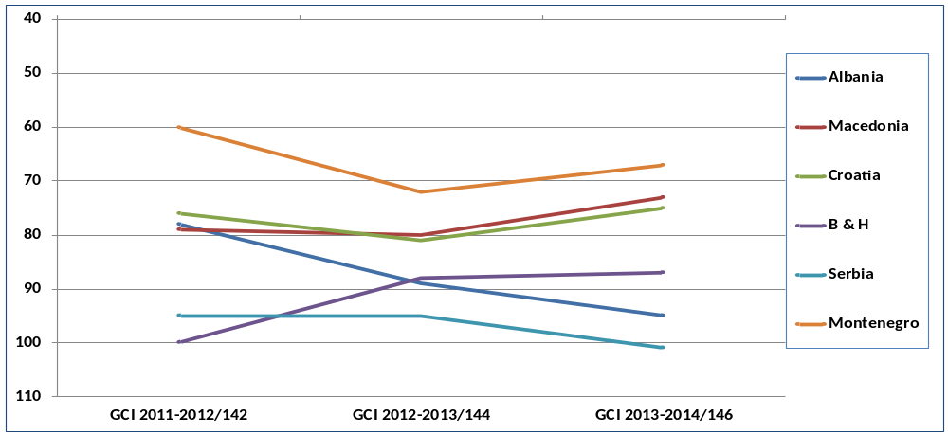
Graph 1. Western Balkan Countries according to Global Competitiveness

In the first place of ranking is Montenegro. Albania is almost the same level with Bosnia- Herzegovina and leaves behind Serbia with 6 seats. After years of steady progress, Albania only in the last 2 year period 2012-2013 has shown dropping in the rankings, which may be to a certain extent the influence of external factors (global economic crises). While increasing the competitiveness of the economy in recent years is dedicated to the government reform measures, but on the other hand the country to be more competitive requires emphasis on factors of innovation, technological readiness, further improvement of infrastructure and consolidation of institutions.

Economic Freedom Index 2014
According to the "Economic Freedom Index 2014" published by the Heritage Foundation and the Wall Street Journal, which covers 10 indicators - from property rights to entrepreneurship - among 178 countries in the world, Albania scored (66.9 points) while ranking 54th place worldwide and in 25th place among 43 European countries.
Albania is classified in the category of moderately free above the global average (60.3) and has a slight increase compared to last year.
Dimensions with higher ranking of economic freedom remain 'fiscal freedom' (92.7 points), followed by 'trade freedom' (87.5), 'monetary freedom' (80.0). Dimensions with the lowest ranking are the 'property rights' (30.0) 'freedom from corruption' (30.4). Report highlights notable structural reforms have included trade liberalization, privatization, and modernization of the regulatory environment. Along with the effective maintenance of low inflation, greater monetary stability has also been achieved.

The judiciary remains subject to political interference, and deeper institutional reforms to eradicate lingering corruption and increase judicial independence are critical to ensuring greater economic freedom in Albania.

World Bank: Ease of Doing Business 2013-2014

The Report “Doing Business 2013-2014” ranks Albania at the 90th position in the world list of 189 countries.
Table 1: Doing Business Indicators

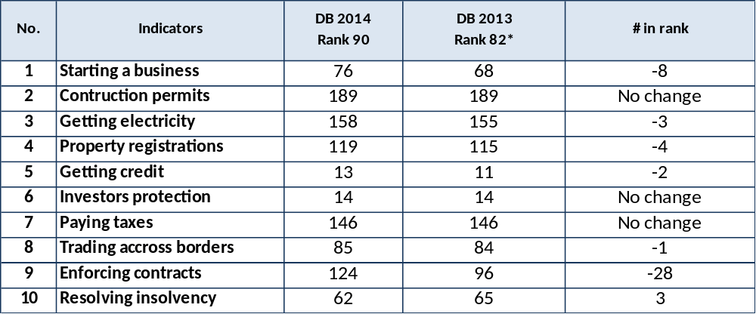

By analysing 10 indicators as shown in the table, many indicators have worsened, specifically: Albania results with an unsatisfactory performance, in ranking in 6 indicators. Only in insolvency resolution is improved. Albania continues to perform negatively in indicators for opening a business, getting electricity, property registration and getting credit; while there is a deep decrease in enforcing contracts.

Albania remains at the same level compared to last year in terms of:
- Indicators for construction permits, but ranked among last countries;
- Indicators for paying taxes, but that is still classified as poor a performance;
- Indicator for investor protection, remain on the same level as the last year.

Graph 2: Doing Business in the region
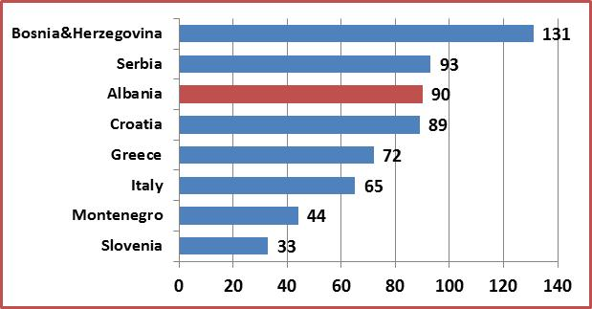

Source : Doing Business database, 2013

3. BUSINESS DEVELOPMENT AND CHALLENGES

Albania is still ranked in low positions on: i) further simplification of the business start-up procedures, ii) reduction of the time of issuing a construction permit; iii) number of days of electric power supply; iv) number of days and procedures for the registration of assets; v) on reduction of customs documents; vi) on the enforcement of contracts; vii) on bankruptcy. The improvement of these indicators and also the consolidation of business and the creation of a stable and structured "vertebral column" of the Albanian business which will constitute the basic frame of the stable Albanian economy is one of the challenges of this strategy.

3.1 Development of Entrepreneurship and SMEs

During the last years the GoA has undertaken important reforms to formalize the Albanian economy. The introduction of the progressive tax, the installation of fiscal cashiers, the reform of the VAT system, the improvements of the procedures of the tax authorities, the success of the National Registration Center and the simplification of the licensing procedures have been very successful reforms and Albania has shown an economic growth, despite the global crisis. Albania has as well leapfrogged on most glo bal reform and competitiveness rankings in the last 5 years. Never-the-less, there is still a significant part of the economy within the informal sector.

The GoA together with the support from the donor community has been a leader in the region in the area of e-government and on-line procurement systems. Major implementation efforts are on the way in the field of taxation, on-line property database and other initiatives in health care and education.

3.1.1 Current Status of SMEs Development
The SME sector has a substantial contribution to the economic growth and employment. Based on INSTAT figures of 2011, contribution of SMEs is more than 73% of the GDP and more than 71% of employment. According INSTAT, the number of active entities by the end of 2012 amounted to 104,275. Compared to 2005, the number of active enterprises in Albania has increased by about 72%. The number of woman entrepreneurs by 27, 4%. Referring to their structure, active enterprises in 2012 noticed that SMEs are dominated by micro enterprises with 1 to 9 employees, which constitute 95.3% of the total number of active enterprises.

Chart 3: SMEs by size Chart 4: SMEs by sectors
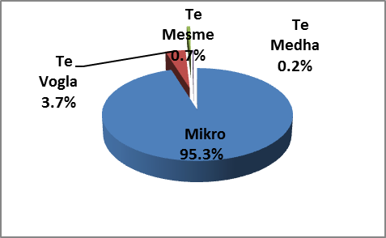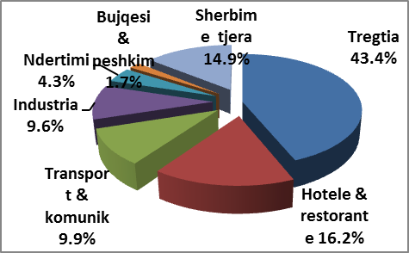
The spread of active enterprises by economic sector are: trade 43.4%, hotels & restaurants 16.2%, transport and communication 9.9%, industry 9.6%, construction 4.3%, agriculture and fishing 1.7% and other services 14.9%. It is to be noted that the composition of trade, hotels, coffee bars and restaurants is dominated by domestic businesses and a a slight shift towards international trade has only happened in the recent years, especially in summer time due to tourists’ inflow in the country.

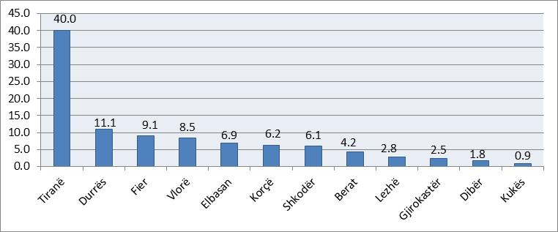
Chart 5: Distribution of SMEs by region

Source : Register of Economic Enterprises - INSTAT 2012

Over 50% of active enterprises operate in Tirana and Durres region. A very slight increase of the number of enterprises has been noticed in the prefecture of Elbasan, Diber and Korca and overall the situation is almost the same as the previous year.

Trade activities, such as hotels, coffee bars and restaurant dominate the economic sector with 59,6%. Trade activities represents 43.4 percent of the enterprises, but with a slight decrease of 2,3% compared to 2011. Only 15,6% covers the producers of goods. Predominance of producers of services is a common phenomenon in all the prefectures. Turnover for 2011 increased by 9% compared to the previous year. This increase was affected by producers of goods are increased by 7.6%, while producers of services are increased by 9,7% compared to the same year.

3.1.2. Financial Facilities and Credit
According to Doing Business World Bank 2013-2014, Albania is ranked 23rd in the world for credit facilities. Based on data from the Bank of Albania, the ratio of private sector credit to GDP, in December 2012, was 40.2%. The annual growth rate of the loan portfolio is about 14%. The banking sector makes for more than 95% of the financial sector and the banks are the major fund providers in the economy. To improve the financing environment of SMEs, in the recent years some measures have been taken in relation to the introduction of credit guarantee schemes for SMEs.
- Implementation of SMEs credit scheme with the support of Italian government. With the official launch of the program in January 2009 lasting until December 2012, the credit loan for SME of an amount of 25 million EUR has funded 79 projects with a value of 17,4 Milion EUR, from which 10 were start-ups. During the same period, a guarantee fund of 2.5 million Euros was available as part of the programme for the SME development that guaranteed bank lending
- European Fund for Southeast Europe (EFSE). EFSE has provided a loan of 20 million EURO for the National Commercial Bank (NCB). 23.8 Million Euro of loans for about 332 clients have been granted so far providing funds to businesses in many different cities and for different purposes such as: floating capital, inventory, and fixed investments assets. The outstanding status for these loans is 17.9 million Euros, while they have a very satisfactory repayment performance.

3.1.3. Small Business Act for Europe (SBA)
According to the 2012 Index of SME Policies (OECD 2012), the development of SME in Albania has received 3.01 points (maximum points are 5), which is only slightly less than the average of the region 3.07 points.
The evaluation has been made on the 10 dimensions according to the Small Business Act (SBA). The performance of the Albanian policies during the 2007-2011 periods has been impressive. If we compare the 2009 Index of SME policies, there are improvements in 6 dimensions: especially, in the fields of business climate policies (such as the registration of companies, licensing of companies, regulatory reform, financing access and promotion of exports). Fields that require improvement are: SME development of human capital and technological capacities as well as payment of commercial transactions.

Chart 5: SME policy index for Albania, year 2012
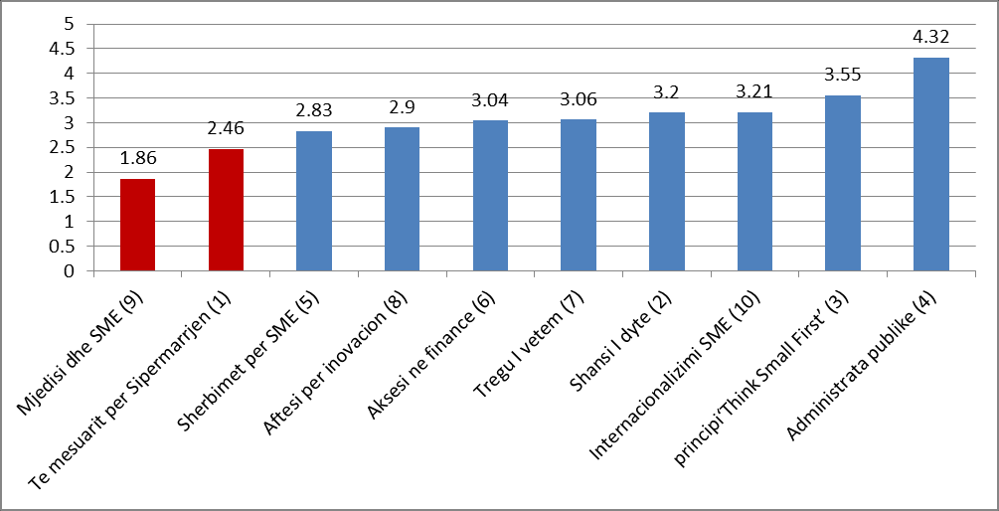

3.1.4 Creative economy & Women’s Entrepreneurship
Creative economy is considered as a promising economic sector with the potential to contribute more to the local, regional and national economy and employment. According to a GIZ study in 2011, the contribution of the creative economy in Albania amounts to approximately 0.5% - 1% of GDP. In most developed countries, the creative economy contributes about 3% of GDP. This can be seen as a potential with a large space for improvement. Creative sector offers about 3,500 jobs, or 0.5% to 1% of the workforce. 56% of all persons in the creative sectors are women with a high concentration in the fashion field (> 90%) and crafts work (78%). A large portion of employment in these economies is occupied by handicraft works with 37%.

3.1.5 Innovation and Technology Development for SMEs
Albania has registered a rapid increase in the number of enterprises, which indicates for a vibrant economy with a high degree of entrepreneurial spirit. With the support of the project IPA 2007 “Supporting SME-s to become more competitive in the EU market”, has been drafted the Business Innovation and Technology Strategy. In order to make possible the implementation of this strategy, in 09.02.2011 it was adopted by DCM no. 104 the Strategic Program for the Development of Innovation and Technology of SME.
The primary methods of innovation used in Albania are: acquisition of new machinery/ equipment’s and recruitment of qualified personnel. The main factors that affect the capacity of firms to absorb advanced technology concerns the investment climate, in which they operate, and the existing skills level and technological capabilities. In terms of skills level, there is a mismatch between skill needs from businesses and graduates’ fields of study. Businesses in agriculture and agro-processing, textile and foot wear, tourism, construction, transport and communication, energy, information communication technology lack specialists and technicians.
The vocational education and training system is still affected by limited involvement of the social partners; a highly centralized system with low responsiveness to local needs; a dichotomy between vocational education and training due to the slow development of occupational standards and programmes that are aligned to labour market needs; and inadequate monitoring and evaluation approaches able to measure the quality, as well as quantity, of vocational education, training and lifelong learning.
The relations between the vocational education and training system and industry are weak and most curricula offer little scope for practicing the skills learnt. The lack of qualifications that reflects the new competencies required by emerging economic sectors and an innovation-driven economy, coupled with labour market information gaps, complicate matters further. The system is still underfinanced, with poor incentives for the participation of employers as well as limited resources invested in upgrading the quality of infrastructure and teachers’ and instructors’ training. The attractiveness of vocational education is still low and perceived as a second best path to tertiary education, rather than a route to labour market entry.
In Albania only 10% of all observed firms provide formal training for their employees, compared to 79% of Slovak firms 48% of firms in Serbia according to a study conducted in 2005 (World Bank, 2009, p. 48). The VET shortcomings in the skills system will be addressed by improving the coherence of the national qualification system; introducing a certification system that includes non-formal and informal learning over the working life; and establishing quality career guidance underpinned by reliable and updated labour market information. Recognition of prior learning, in particular qualifications and skills gained in migration for both, Albanian citizens and foreigners will be considered in order to fully exploit the impact of migration. In general the potential of the Albanian Diaspora for filling in the skills gap remains untapped.

3.1.6. Challenges in the developments of SME-s

Based on the following SWOT analysis, on the SME development trend it is noted that:

- SME financing. Although the financing level of the SME has experienced an increase in the last years, it is currently considered insufficient to stimulate a rapid growth. In the same way, SMEs and start-ups, in particular, face many difficulties in obtaining credit from the banks as the cost of credit is relatively high. There are no favourable conditions for businesses, particularly for the highest level of the collateral 120-150%, when it is needed for investment in machineries and equipment’s. Support policies for start-ups are still missing. There is a lack of alternative financial resources for SMEs, such as venture capital, innovation vouchers and business angels.
- Internet and electronic trade. During the past years in Albania, the number of SMEs that use second-generation web services has increased, driven by the younger generation of entrepreneurs and managers. According to AKEP, in 2011, internet coverage rate was over 50%, which is still lower compared to 67.6% average in the EU. Despite improvements in the legal framework, only 10,000 out of 100,687 active businesses have broadband internet. Actually in the country there are three operators that offer the mobile broadband service based on 3G.
- Creative economy. There is need to intervene with concrete policies in this sector, following: i) regulatory measures to remove administrative and legal obstacles; ii) improvement of professional training and the education system (on all design/projects and handicraft activities); iii) legal and financial stimulating measures in supporting this as well as iv) improvement of organizational capacities that represent this sector.
- Inclusion of the social corporate responsibility, CSR, in increasing business competitiveness.
  - Corporate Social responsibility is a key part of the new strategy “Europe 2020”, which aims to build an integrated approach on “a fast, sustainable and inclusive growth”, within a general vision of a social market economy.
  - The inclusion of the social responsibility in businesses is a challenge for the improvement of their competitiveness. It is a new policy for Albania and it should be included in the agenda for sustainable business development.
  - SME innovation and technological development

SWOT ANALYSIS of SMEs:

STRENGTHS:  - Implementation of regulatory reform in support of improving of business climate and reducing the cost of doing business;  - The development of ICT;  - Implementation of strategic documents of SME development, especially the continuous reduction of administrative barriers;  - National Registration Center, NRC, as a one stop shop, where the registration is made in one day at the cost of 100 ALL;  - National Licensing Center, NLC, as a one stop shop where most of the licenses are granted within 2-4 days, whereas licenses that are granted by other institutions are issued within 10-30 days (building permits excluded);  - Fiscal Reform, progressive tax.  - The establishment of AIDA & BRIC.  - Albania is become part of the SME European network, EEN;  - Sustainable macroeconomic growth.  - Equal treatment of local and international investors. | WEAKNESESS:  - Lack of financial support schemes for business start up;  - Poor access to financing sources from enterprises and micro enterprises;  - Lack of alternative financial resources for SMEs, like‘venture capital’, ‘innovation vouchers’, ‘business angels’;  - Lack of services for the business;  - Poor innovation performance;  - Deficiencies in technological skills of enterprises;  - Lack of areas and industrial parks;  - Lack of business incubators and clusters;  - High level of informality in the economy; lack of credible statistics in the analyzing of the economic indicators;  - Limited Access to private financing.  - Problems with property rights;  - Difficulties in obtaining construction permits, electric power supply, property registration and payment of taxes;  - Low levels of R&D human capacities (especially in the technical fields);  - Migration regulation not conducive to Diaspora engagement, return and mobility of foreign businessmen and entrepreneurs and other categories of economic migrants (inter-corporate transferees, investors);  - Limited consultation with the interested parties and interest groups;  - ISO management system, is in place in only a small  number of companies;  - Lack of gender-sensitive support programmes for female entrepreneurs  - Limited IT skills & “literacy”, access to internet.
OPPORTUNITIES :  - Implementation of the new strategy for the improvement of SME competitiveness via transfer of technologies and innovation, as part of the business and investment;  - The government is fully committed to further improve the business climate;  - The existence of SME Donor Forum to coordinate the creation of synergies in international cooperation;  - Functioning of portal E-government www.e-albania.al;  - Obtaining of EU candidate status;  - Empowerment of business associations according to the sectors and increase in cooperation between industries and SMEs;  - Albania can move forward towards clean energy and the use of resource efficiency in the South East region;  - Increase the awareness of sustainability in this phase of sectorial development. | THREATS:  - Unfair commercial practices are considered to be one of the main obstacles on the development of SMEs;  - Frequent changes in the tax legislation.  - Economic crises in the countries of the euro zone and especially in neighbouring countries such as Greece and Italy;  - Lack of qualified human resources, especially among youth  - The laws enforcement of is more important than just their approximation to the EU legislations, gender stereotypes and gendered occupational profiles in all levels of education (particularly in higher and professional education) leading to suboptimal use of human resources and limiting employment opportunities particularly for women and girls;  - low number of women in leadership positions, lack of role models, lack of representation in official decision-making bodies and associations.

3.2. Industry and Development

3.2.1. Non-food industries development
This industry has had some special development features during these years such as:
i) Metallurgical industry, which is represented from the recycling of metal scrap and ferrous chrome production that have increased from year to year: it has used existing premises and its industrial renewal of technology that has made possible the exit in the internal, regional market and beyond. Actually, there are processed about 600 thousand tons of metal scrap and produced about 23 thousand tons of ferrous chrome per year. There is large potential for this industry in the metallurgical processes for the treatment of copper and nickel ores.
ii) Mechanical industry, which is represented by micro enterprises with 2-5 employees that mainly produce metal constructions, aluminium products for construction, special spare parts for various industries, etc. The total number of enterprises in this industry is about 700. It uses the professional experience of the workers and the market demand for specific services. Its development is conditioned by construction and infrastructure development. This industry failed to develop the production of spare parts and technological equipment required by certain branches of industry, especially from mining, food, focusing on this period only in the sector of services and maintenance. This would be one of its directions of development in the years 2014-2020.
iii) Wood processing industry is traditional and currently has a normal development. With its products is meeting better and better each day the customer requirements with local wood products and is becoming more present even in the regional market. Today, the wood processing industry counts about 700 wood processing entities nationwide, 200 of which produce sawn material and 500 entities dealing with the manufacture of articles of furniture, in which are employed around 4500-5000 workers, with revenues that account for about 20 -22 million Euro, its exports constitute a value of about 4 million Euro in wood semi- fabricated materials.
iv) Chemical industry built after 1990s is characterized by many small, medium, large private enterprises, which realize products in the field of chemical industry as paints, detergents, Styrofoam, oils, glue for building products.
v) Textile and clothing industry is represented mainly from the production of clothing and a small production of textile and wool materials using part of the existing facilities, the cost of cheap labour, workers experience. It is noticed the phenomenon of joint stock companies, mainly Italian, Greek, German, which have brought the modern technology. In this branch today the value of exports in 2011 has reached 238.6 Million EUR. Number of employees at the end of 2010, according to INSTAT reached about 15 thousand employees
vi) Leather and footwear industry is represented mainly by inward processing companies that work with the purchaser material. This industry exploited the same opportunities as well as that of clothing. In this branch according to INSTAT are employed a 10.600 workers and the value of exports for 2011 reached 216 million EURO
vii) Glass and ceramics industry is represented from the development of artistic handicraft production, as well as that of the coarse pottery and hydro-sanitary tiles. Their products in their vast majority, inherit and follow the earlier representation of the country tradition, that of the coarse pottery. As a raw material for their products is used domestic raw material, the level of craft and technology is still handicraft and affects the increase in quantity and quality of their production. In general these lines are considered small, in which do not work more than two to four specialized employees.

3.2.2. Challenges in the development of industry
The challenge of the development of industry consists in the orientation of the investments that have an impact in the development of products and of sectors of added value. The aim is to have a further deepening in the liberalization process of the internal market, to introduce new energies for the: i) industrial development, product research and development, new export products, suitable conditions for the promotion of entrepreneurship culture, on business networks, on technological and innovation cooperation ; ii) development of market institutions combined with the coordinating role of the state with the balance in favour of the functioning of the free market; iii) the steering of the implemented policies towards the increase of the inflow in foreign investments and in the development of infrastructure, towards the employment of the technological capacities, improvement of legislation, iv) improvement of service efficiency offered by the public administration in order to support industrial development, research and development of new products with the aim of increasing the value of the country’s exports and that of businesses;

3.3. Export Developments

3.3.1. Developments in the context of trade policy
Trade policy which is part of the development of exports is inspired by the guiding principles and of the WTO. After joining the WTO, all trade policies in Albania are based on (i) a strategic document, which is the report of Albania's membership in this organization and (ii) of the Uruguay Agreements. Through these documents it is ensured that Albania guarantees the absence of:
- Quantitative restrictions on imports or exports, except in cases of environmental protection or assistance to fragile industries;
- Subsidies for exports;
- Any kind of tax on exports;
- Or any kind of ban on export licensing, different from the memorandum of prohibition or licensing in exports.
WTO principles have found expression in all free trade agreements in Albania. Since July 2007, a free trade agreement is in place in the Western Balkan countries, CEFTA 2006. According to this agreement, within CEFTA countries all goods are traded without customs duties, with the exception of some agricultural products originating from Bosnia-Herzegovina. This agreement after several rounds of negotiations has provided:
- Exports of industrial products originating from Albania without customs tariffs and no quotas in at all CEFTA countries;
- Exports of agricultural products originating from Albania without customs tariffs and no quotas in all CEFTA countries, with the exception of some products with Bosnia and Herzegovina.
Since May 2008, a free trade agreement with Turkey, which has created a free trade zone between the two countries, is in place. This agreement makes it possible that:
- Exports of Albanian originating industrial products leave without customs tariffs and no quotas;
- Exports of agricultural products originating from Albania leave without customs tariffs and no quotas, (mineral waters, vermouth, alcohol, cocoa and cocoa products, pastry products)
- Albanian originated products, with export quota, without customs duties and quotas on these exports without restriction but with customs tariffs, as wine, cheese, eggs, honey, plants (including plant scion) tomato, onion, cabbage and cauliflower, carrots; cucumber, beans, frozen vegetables, dried vegetables, our peas, spices, watermelons and melons, frozen fruits, medicinal plants, canned fish, chocolate, canned fruit and vegetables, jam fruit juices, tomato juice, ice cream.

Since November 2011, it is in force the free trade agreement with EFTA countries. Member States of EFTA countries are Iceland, Switzerland, Norway and Liechtenstein. This agreement makes possible that:
- Albanian origin exports of industrial products to leave without customs tariffs and no quotas;
- Albanian Origin exports of some agricultural products to leave, according to the EFTA Member States, with quotas, without customs duties, such as olive oil, fresh vegetables, medicinal plants, etc.;
- Exports without restriction but with customs tariffs for all other agricultural products.

3.3.2. The trend of exports

In 2012 the growth of trade volume is 54.5 million Euro or 1% more than in 2011. In 2012, the total trade volume comprised 72% of imports and 28% of exports. During 2012, exports increased by 8% and imports decreased by about 3%. The above values are compared with a year ago. Trade volume in 2012 compared to 2007 levels is increased by 57%. Since 2007 export has increased 2.1 times the size by 2012.

Graph 10: The flow of goods 2007-2012 year in Mill. ALL
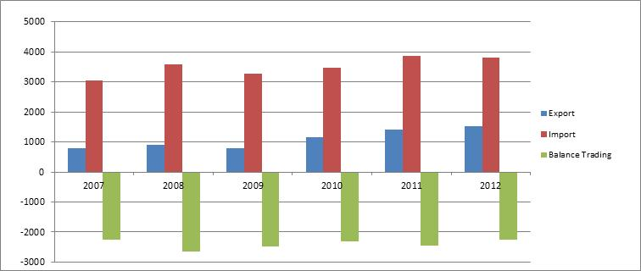

Openness of the economy as the ratio of trade volume to GDP has been steadily increasing. In
2012 it was about 54.48% to 42% in 2006. 2009 is the only year in which the ratio of exports and imports in GDP had a slight decline. In 2012 this ratio of (GDP in 2012 is forecast) is 54.4%.

Graph 10-1: The openness, as the ration of trade volume to GDP
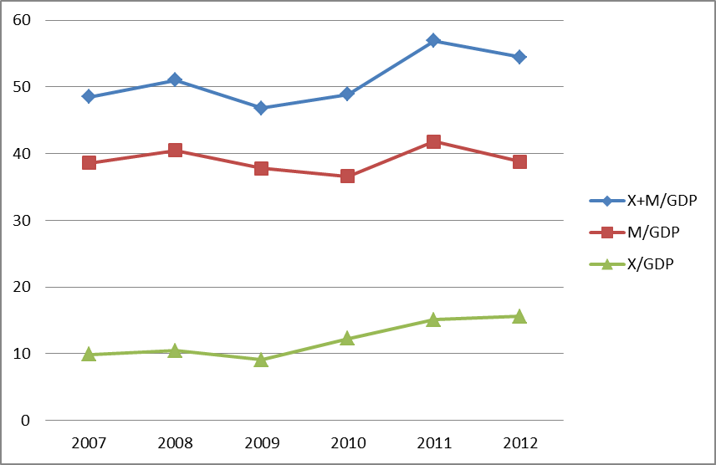
Source: MEDTE

Percentage of coverage of exports to imports has increased in favour of export in the last 5 years. Specifically the coverage of exports and imports for 2012 is 40.3%, as a result of imports and exports growth compared to 2009, which was 23.9% but it is seen an increase in the percentage of coverage of exports toward imports in the last 6 years with reference to the above table. The balance of trade in goods and services has improved as its ratio toward GDP from 2006 to 2012 respectively from -24% to -20%.

Exports by commodity group
Potential sectors for exporting products are still those who are already called traditional sectors:
- Textiles and footwear remain a considerable potential to increase export volumes. This sector occupies 32% of total exports.
- Minerals and oils in Albania constitute another potential which for the year 2011 has reached 27% of total of exports.
- Construction materials constitute about 13.5% of total exports.

Table: Exports in million Euros
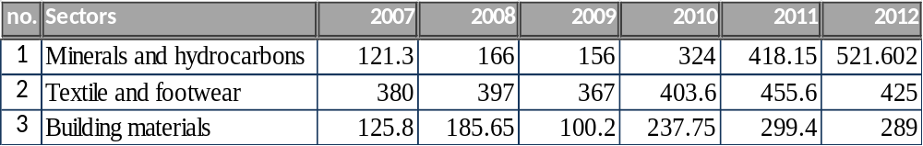

Source: MEDTE

Exports of key items in 2012 have a significant increase from 2007, respectively 4.2 times mineral and hydrocarbons, 1.1 times textiles and footwear, 2.3 times building materials.

Exports by destination countries
Exports to EU countries make up for 72.5% of all exports and with an increase of 26.5% compared to the end of 2010. The main country’s exports go to: Italy, Greece, Spain, Germany, Malta, etc. As it is seen from the graph below, a key partner in our exports by 53% is Italy, followed by Greece by 5.2%.

Graph 11. Exports of goods by specific weight and countries destinations for 2012
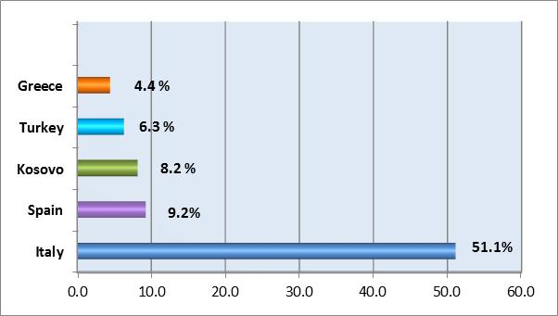
Source: MEDTE

After the implementation of CEFTA in 2012, Albanian exports to member countries of CEFTA followed a marked change occupying a specific weight of 12.1% of total exports which constituted 10.2% in 2010. Compared with 2011, in 2012, exports to CEFTA countries grew up with 5%. Kosovo has traditionally been the country's main exports within CEFTA, which in
2012 has a specific weight of 69% of total exports to CEFTA.

3.3.3. Challenges and problems in the field of exports

In the last decade government policies and the regulatory framework for business have been based on the principles of good governance with transparency as a primary focus, forecasting and simplification of practices. The liberal tariff regime and the network of free trade agreements, is further expanded with the extension of the implementation of the cumulative rules of origin. It has enabled the chances for the Albanian exporters to access new markets.

Business in Albania still faces many problems and the government is trying to solve it since it has a direct impact in the competitiveness of Albanian economy. A special focus is given to the upgrade of the competitiveness of the domestic products, reducing the needs for import, the increase exports and the penetration of products “Made in Albania” in new markets. These issues remain real challenges for the exporting companies:

- Increase the cooperation between the public and private sector
The increase of export requires the strengthening of the cooperation between the government (national and regional level) and the private sector. The need to strengthen the agency of export promotion (AIDA), especially for SME export companies, to have more training and vocational institutions and better equipped with training materials and professional experts (teachers); creating close contacts between universities, departments of scientific research working very closely with 3-4 sectors promising for export potential; Improve the level of collaboration and cooperation, it’s an imperative requirement in order to better respond to the demands of the international market for Albanian products. The exporting companies as well as those that offer export potentials should be supported with services and supplied with information on their competitors in the global market.

- Poor physical infrastructure
Poor physical infrastructure increase substantially production costs and are an important obstacle for exports. The experience of the countries of the European market and of some countries in the region shows that an effective export strategy requires ongoing improvements of the physical infrastructure. It means that the government will consider the establishment of all facilitations of ensuring the transport and marketing of export products, starting from rural areas, export processing centre, continuous supply with electric power and water etc.

- Difficulties in fulfilment of quality standards
A big challenge is the developments of exports in compliance with the international standards of quality, health and safety. International experience shows that an effective way to increase exports is to obtain the support of the exporting companies, public agencies in support of exports, accredited labs, product certification, conducting of training with the aim to reach the necessary level of quality.

- Lack of efficient export financing schemes
A weak financial system is a big obstacle to promote exports because it can increase transaction costs. In particular, access to finance constraints poses a significant barrier to exports, especially when the state budget grants options are limited. In the banking market the main obstacles consist in export crediting, high interest rate (which partly reflects higher investment risks), and some issues related to the risk evaluation activities of the banking sector.
Other obstacles from business perceptions
- Low quality of products and services provided for their needs;
- Limited capacity to produce high-quality processed products;
- Limited managerial skills to position products "Made in Albania" in regional and international markets;
- Lack of knowledge about the marketing of products, causing difficulties for the entry into the market of new export products;
- The issue of VAT refunds brings directly to the lack of liquidity of these entities;
- Therefore, it is associated with increased costs due to credit, increased costs due to penalties along with interest;
- Also the lack of tax payment in due time, coming due to lack of liquidity. The lack of VAT reimbursement and cash flow problems, affecting 8-12% reduction per year of total turnover of exporting businesses;
- High rate of informality, which differ in different sectors;
- High cost of transportation for the export of Albanian products. This concern is particularly sensitive to distant markets more than 1,000 km (mainly to the markets of Austria, Germany, Holland, France etc.) that markets are actually more sustainable and more powerful for Albanian exports;
- Identification of export partners;
- Reliability of production (constant quality, type, standard, volume, schedule) particularly with regard to agricultural products (and specifically for bio-organic products).

3.4. Development of the performance of Foreign Direct Investments (FDI)

3.4.1. General Overview

Albania is one of the leaders in attracting FDI in the Western Balkans. Significant improvement in road infrastructure, electricity, water supply, as well as major improvements in public services followed by well-designed marketing initiatives has attracted key investors in energy, petrol industry, infrastructure field as well as in retail and the financial industry.

Energy: Concessionary projects in the energy sector aim at increasing the production of electricity and the diversification of energy resources to renewable energy. The strategy of the Government for increased electricity supply security is the exploitation of the power potential in the country. Meanwhile Albania is moving towards a regional energy market and participation in regional power exchanges. Inter-state interconnection lines have become operational connecting Elbasan-Tirana and Tirana-Podgorica. Additional investments on two submarine cable lines with Italy and interconnections between Tirana-Prishtina, Tirana-Skopje lines will eventually close the bypass regional electricity transmission involving Albania.

Developing the country’s infrastructure has been the priority of the Albanian Government. In partnership with the private sector, it has greatly developed and rehabilitated the road network to increase the efficiency and capacity and improve both regional and continental transport links. The main highway currently stretches from the port of Durres to the Kosovar border is now a reality and Kosovo is developing its part of this important Project, linking Albania with the rest of central and Eastern European markets. In just a few years, the country will be linked with its mainland neighbours by high quality roads facilitating transport and trade.
"Mother Teresa" Airport has undergone important modernization in last decade and is one of the most successful concessions. Albania is also modernizing its sea ports by increasing their capacity and efficiency levels. Recognising the value of its port infrastructure, the Government has a development agenda to better meet increasing needs and demands. FDI is playing and is expected to play a huge role in this thriving sub-sector.

Telecommunications has been among the most dynamic service activities in Albania. They developed mainly via privatization and subsequent investments of foreign investors and to some extent through domestic investments. Due to post-privatization investments and investment by the new entrant, the number of subscribers of mobile phones at the end of 2011 reached 5.2 million. This level of mobile phone penetration 187% is similar to that in developed countries such as Germany. The Presence of foreign companies, together with Albanian operator Plus have increased the competitiveness in the market, providing better quality services with low cost, comparable with the region. The telecommunication market is expected to grow simultaneously with the growth of broadband and 3G services (high speed internet) provided by 2 operators Vodafone and AMC and Government project of digital Albania (AKEP 2012)

The financial services industry has also undergone sweeping changes due to FDI. The entry of foreign banks and the takeover of domestic banks consolidated the banking system. Overall, foreign banks appear to have had a positive influence on the efficiency and stability of the banking system in the economy. They have strengthened risk management and corporate governance through a more efficient allocation of capital and increased competition, and have introduced more sophisticated and up-to-date banking services. However, the overall positive features by international banking standards do not satisfy all the needs of the Albanian economy yet. SMEs still have limited access to bank financing and there is need for improved credit guarantee schemes. It is to be noted that the interest rate provided by the banks to SME is still high to be afforded. Also, banks usually request for collateral, which makes the credit sometimes difficult to be awarded to the SME. The potential of Albanian Diaspora in funding SMEs in Albania though guarantee funds or investment schemes has not yet been explored.

3.4.2 FDI in figures

In South-East Europe, FDI flows almost halved, mainly due to a decline in investments from traditional European Union investors suffering economic woes at home. Before the onset of the financial and economic crisis, South-East European countries made significant progress in attracting FDI, resulting in an increase in inflows from $2.1 billion in 2002 to $13.3 billion in 2008. The surge in FDI to the region, especially after 2006, was driven largely by the economic recovery, a better investment climate and the start of association (and accession) negotiations with the EU. In addition, relatively low labour costs, easy Access to European markets and the privatization of the remaining State-owned enterprises gave a boost to FDI flows. This positive trend was reversed in 2009, with FDI inflows falling sharply in all countries of the region. In contrast, Albania keeps the trend stable during these years. Croatia and Albania were the largest recipients of FDI flows in the region for the year 2012 (graph 12)

Graph 12: FDI flow in SEE countries 2010-2012 in Million USD
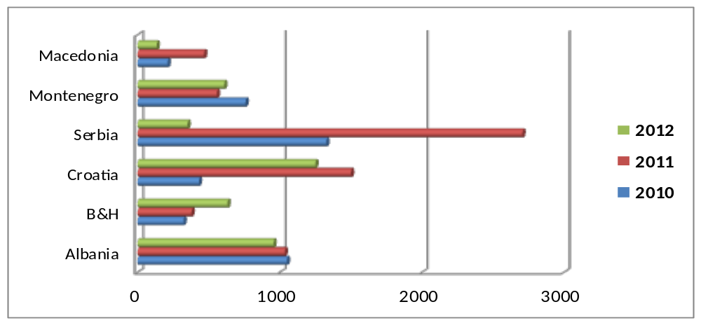
Source: UNCTAD WIR 2013

Albania has the lowest FDI stock relative to GDP among the countries of South-East Europe which is quite different from the relative size of Albania’s inflows in these years. This is due to the fact that FDI in Albania is a very recent phenomenon and much of the stock has been accumulated over the past few years only, while the other counties have received FDI for a longer period of time. Albania has also had more rapid economic growth in recent years than its regional peers, which has lowered the magnitude of its FDI per GDP indicators (AIR 2011)

Table 3: Main FDI indicators 2006-2012
Indicators | 2006 | 2007 | 2008 | 2009 | 2010 | 2011 | 2012
FDI flow | 259 | 481 | 665 | 717 | 793 | 746 | 746
in % to GDP | 3.6 | 6.1 | 7.5 | 8.1 | 9 | 8.1 | 8*
FDI Stock | 1054 | 1688 | 2040 | 2261 | 2667 | 3036 | 3796
FDI per capita | 80.9 | 150.3 | 207.8 | 224.1 | 247.8 | 266.4 | 266.4

As mentioned above inflow of FDI in Albania has maintained a positive upward trend over the years. The biggest growth was in 2009 with 793 million euros FDI. Compared to 2006, FDI worth nearly tripled, from 259 million euros in 2006 to 746 million euros in 2012. FDI inflow toward Gross Domestic Product (GDP) has been increased continuously, from 3.6% in 2006, has reached and 8.1% in 2011. The same ratio is also in 2012.
For the 9 months period of 2013, the FDI figure was € 712 million Euro, with a 26.7% increase compare to the same period of the previous year. The most important sectors that have contributed to the value of FDI are the energy, financial, telecommunications and manufacturing industry.

Industrial sector (including, manufacturing, mining and mechanical) is considered the main sector in attracting foreign investments with about 50 % of FDI inflow in 2010 and 2011. The other sectors are financial with 15%, distribution and other services 15%, electricity and gas 14,1%, telecommunication 9% (table 4).
Table 4: FDI flow by economic activity 2007-2011 (in million Euro and as % toward the total)
Activities | 2007 | 2008 | 2009 | 2010 | 2011
Agriculture, fishing | 2 | -54 | -9 | 0 | 0
Construction | 51 | 147 | 19 | 44 | 0
Industry | 56 | 369 | 300 | 394 | 352
Electricity, gas | 4 | 2 | 143 | 88 | 105
Telecommunication | 196 | -61 | 84 | 97 | 67
Financial intermediation | 136 | 167 | 120 | 138 | 110
Distribution, other services | 25 | 95 | 59 | 33 | 111
TOTAL (Value) | 480 | 665 | 717 | 793 | 745
Agriculture, fishing | 0.4 | -8.1 | -1.3 | 0 | 0
Construction | 11.0 | 22.1 | 2.6 | 5.5 | 0
Industry | 12.0 | 55.5 | 42.0 | 49.7 | 47.2
Electricity, gas | 1.0 | 0.3 | 19.9 | 11.1 | 14.1
Telecommunication | 41.0 | -9.2 | 11.7 | 12.2 | 9.0
Financial intermediation | 28.3 | 25.1 | 16.7 | 17.4 | 14.8
Distribution, other services | 6.2 | 14.3 | 8.2 | 4.0 | 14.9
TOTAL (in %) | 100.0 | 100.0 | 100.0 | 100.0 | 100.0
Source: Bank of Albania, 2011

The sectorial composition of the stock of FDI (graph 13) has undergone significant changes over the last 5 years. So the services sector from dominated sector with 66% of the total FDI stock in 2008; fell to 59% in 2010 and further in 2011 it fell in 47%. FDI stock was expanded in other sectors of economy, especially in mining sector. The share of mining sector FDI increased almost twenty times in four years from negligible in 2006/2007 to almost 21% of the FDI stock in 2011. This is the result of the concessionary policy of the Government. A similar development took place in the energy sector which increased its share from less than 1% in 2008 to almost 7% in 2011. In the processing industry is invested about 16% of the FDI stock.

Chart 13: Stock of FDI by sectors of economy Chart 14: FDI by country of origin
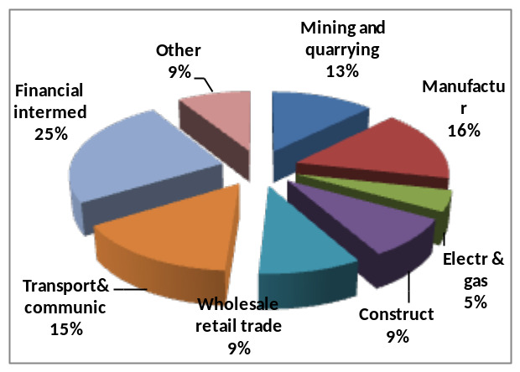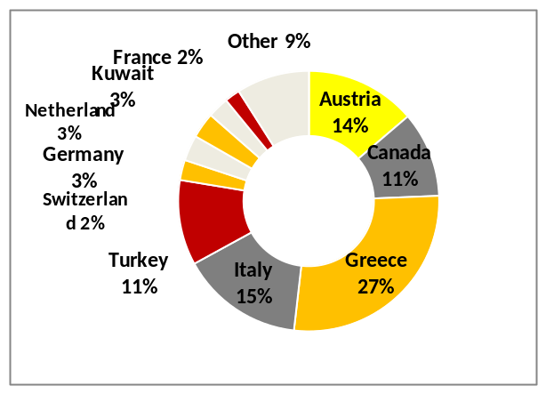
Source: Bank of Albania, 2012
By country of origin of FDI in Albania, ranking of countries has undergone constant changes, with Canada for the first time leading the position for the capital invested by the end of 2011, which until now was chaired by the European Union countries; Greece and Italy, our main trading partners. But the effects of the crisis have made their investments to decline in Albania, especially from Greece, which although is ranked in the second place with 17% of the stock of FDI has declined by 6 percentage points from 2009. These two countries have also the highest stock of Albanian emigrants, Greece, 574,840 and Italy 449,657 hence the decline is also affected by the shrinking of migrant’s investment in Albania fearing of a negative impact of the crisis to their savings and investments. In general the potential of the Albanian Diaspora for financial and human investment in Albania remains largely untapped.

The Greek investments are focused on the telecommunications, financial intermediation and the processing industry. In the third place is Austria with 16%, while Italy ranks fourth in the ranking with a drop of 3 percentage points compared to 2009. Italian Investments are mainly focused on construction and manufacturing sectors. Also they are present in the services sector, mainly in the financial sector. A special phenomenon of Italian investments is that they are represented by small and medium enterprises which make the majority of them in our country. Turkey is in the fifth place followed by Netherlands, Cyprus, Germany, Switzerland, etc.

Referring to INSTAT, the number of foreign and joint-venture enterprises till the end of 2012 reached 3811 with an increase of about 7% compared to 2011, representing 4% of the total number of active enterprises in the country. From 2006 to 2012 foreign enterprises in Albania have increased approximate by 23%.

By country of origin, the largest number of enterprises comprise those originating from EU countries, and within them, the majority of them are from Italy, followed by Turkey, Greece, Kosovo, Macedonia, Germany, USA etc. In their total, foreign and joint enterprises are separated in the production of goods that make up 32% of total enterprises in the services sector and occupy 68% of the total. In a detailed listing of foreign and joint companies according to sectors: trade makes 33%, industry 20%, other services 27%, construction 11%, transport and communications 5%, hotels, cafés, restaurants, 4%, 1% agriculture and fishing. In some activities, branches of foreign companies makes the majority of companies active in the sector, for example more than half of them operate in the extraction of oil, more than a third of them in manufacturing sector aid for transportation equipment, electrical products and machinery for oil, gas and energy. These are activities with high capital investment, where SMEs with local ownership are rare. As in other activities, such as retail trade, hotels and restaurants, the presence of local SMEs is dominant in number.

3.4.3. Challenges in the development of Foreign Direct Investments

In achieving its objectives in the field of foreign investments, Albanian economy encounters a number of challenges that could undermine its efforts for attracting foreign investments, in particular the small domestic market and limited purchasing power which might be discouraging to many medium and large investors, and the high competition posed by neighbouring countries which are also pursuing aggressive foreign investment promotion strategies.

According to the Indicators of the World Bank on Global Government (WGI), the internal market is still faced with the strengthening of laws, followed by controls against corruption, government effectiveness and regulatory quality. In the specific criteria’s Albania still perform poorly, especially lagging behind, in construction permits, payment of taxes/tariffs, obtaining of ownership titles, enforcement of contracts etc. Albania has a low level of expenses on scientific research and innovation, low levels in the technological innovation, business sophistication, as well as a low level of the development framework of industrial clusters and technological incubators. To further improve the competitiveness of Albania as a destination for foreign investments, it is required the deepening of reforms and addressing various barriers to investment:
- Enforcement of law and regulatory framework.
Although Albania is part of many international agreements and conventions for the settlement of investment disputes, there is a need to set up specialized commercial courts in different cities beyond the capital. Moreover it should increase the capacity of courts and develop alternative dispute resolution mechanisms.
- Obtaining of property titles. Many properties cannot be registered with clear ownership title due to legal constraints caused by conflicting laws or gaps in applicable law, an absence of appropriate procedures, and inconsistent application of the law. Inability to register property with clear title prevents security of ownership and inhibits economic development. Incomplete territorial planning also reduces certainty for potential investment. The government will address issues related to simplification of the registration procedures, transactions contract standardization, further developments in the IT services for a better cooperation between the involved institutions and on line availability of documents for control and transparency.
- Development of economic areas and industrial parks. So far there are approved by decisions of the Council of Ministers 10 economic areas; nine with industrial park status and one as a free zone.
- The need of a qualified work force in order to respond to the needs of the labor market and foreign investors. There is a gap noticed between the needs of the private business and those graduated from higher education system, quantity and quality of secondary schools and university degrees, professional qualified and experienced labour force, quantity and quality of vocational training, business and managerial training institutions
- Informal economy still remains at high levels and damages the environment of doing business because of unfair competition faced by firms in the market. Despite the progress and cooperation of responsible institutions such as Tax Administration, State Inspectorate of Labor, Ministry of Economy, Trade and Energy, labor unions and chambers of commerce, a lot still remains to be done.
- Efficiency of public administration at central and local levels. Bureaucracy, the level of services and public administration capacity building remains an important factor for the investment climate in general. More attention should be dedicated to the sustainability of public institutions from policymaking to implementing ones by avoiding cases of turnovers and away from politicized public administration.
- Strengthening of the intellectual property rights. In general and those foreign investors in particular are sensitive to respecting intellectual property rights, which in Albania are at low levels.

4. RISKS THAT CONSTRAIN THE SUCCESSFUL IMPLEMENTATION OF THIS STRATEGY

Progress of Stabilization Association process with EU. In general, Albania has implemented all the obligations deriving from the SAA. The opening of the negotiations in obtaining the candidate status, fulfilment of the objectives set by the EC, is at the same time an important condition for the financing of projects by the EU, helping in this way in the implementation of the measures foreseen in this strategy.

The reforms program in the continues improvement of business climate. The undertaken of the regulatory reform in order to improve the business climate, the Government considers as a continuous improvement process. Since March of 2006 which was approved Action Plan are set out the main issues to be reformed, the steps to be followed to improve the regulatory environment in view of the services provided to the business, and the development, management and monitoring of regulatory reform in order to implement it in the most efficient way. The purpose of this institutional reform in the coming years is to ensure continual deepening of reforms. These reforms, which fundamentally related to increasing transparency, reducing the cost of doing business, the effectiveness of public institutions and services offered, as well as increased institutional performance, constitute the real challenge in the process of economic development and integration of the country.

Efficient synergy in all activities for the improvement of Albanian image in International levels. A lack of synergy between the institutions that contribute in the improvement of Albanian image in the world (AIDA, AKBN, and National Tourism Agency etc) would have negative consequences, in attracting of foreign direct investments as well as in the creation of industrial areas and parks with the support of foreign investors that make the most important chapters of this strategy.

The competitiveness of products and services is guaranteed by the functioning of an innovation system at the national level. There are many actors and specialized agencies like AKTI, BRIC, Scientific Research Centres, and Universities that operate and contribute to the establishment of a national system of innovation. The strengthening of human capacities and strengthening of AIDA and BRIC are important conditions in fully involving businesses into the dynamics of innovation and ensuring interaction with the interested actors. The absence of projects or funds from the BRIC budget would pose a risk for the implementation of the measures foreseen in this strategy.

Finding the necessary funds for the implementation of activities and of respective measures for the purposes of the objectives in this strategy.

The realization of the objectives and action plan for the implementation of this strategy is quite a difficult challenge. Costs provided for the realization of the objectives will be met partly from the state budget. Priority objectives of this strategy, as, for the development of entrepreneurship and SMEs, export development and integration into regional markets and encouraging foreign direct investment, intend to be funded by the IPA2 program. The risk lies in the fact that other public institutions intend and expect to be funded by IPA2 program, which would make it difficult choosing these sectorial priorities. Funding will be even from other programs as COSME, EDIF regional projects, etc.
Part of the objectives and measures for their implementation could also covered by promoting development of programs and projects in partnership with the private sector, through the implementation of PPP projects. This would be considered an effective political lobbying and attracting private capital into the economy, trying to maximally promote and expand this cooperation model.

III. Vision, policies and objectives of the strategy

1. STRATEGY VISION

“A competitive Albania with a dynamic entrepreneurship and productive industry”. This strategy is in full compliance with the SEE Regional Strategy 2020 and 5 pillars that it provides, ensuring implementation in both national and regional level. It will affect the economic development of the regions, based on the competitive advantages they can offer. The strategy will focus on:

A competitive Albania, which aims at a more dynamic economy with increased levels of foreign investment, increased diversification of exports, and incentives that stimulate the creation of new businesses. The need to continually improve Albania's competitive position against its regional neighbours, European partners and global level is already part of the national ambitions. Attention will be focused towards Albania's natural competitive advantages, improvement of productivity of human and natural available resources, untapped potential mobilization of Albania in terms of natural resources, agricultural land and tourism development, geo-strategic position for trade and transport and development of energy, as a prerequisite for the growth of industrial production. Creation of a partnership between government and business, related with the needs for the improvement of technology, innovation and ability to prepare "skilled workforce".
- A country that stimulates the development of entrepreneurship and SMEs by continuously improving the business and investment climate and reducing administrative barriers and operational costs. In 2020, Albania will have improved significantly the legislative and the institutional framework for SMEs by focusing on the promotion of the entrepreneurial potential of SMEs. Albania aspires to become a leader in the South East European region in accordance with the key international parameters, by creating a business friendly environment, using benchmarks such as the World Bank ‘Doing Business’ Index and the SME Policy Index for Western Balkans and Turkey.
- Development of a productive industry sector, capable of processing raw materials in the country and increasing the added value, through, investment promotion and application of new technologies, clean production methods, and the necessary professional skills that promote the creation of a solid base for a competitive industry.
- In 2020, Albania will have realized its full industrial potential by combining the rich mineral potential with the power generation potential. Albania will move towards an integrated manufacturing of industrial goods ready for export in the global markets. Albania will aim to exploit the mineral wealth by supporting investors with a fast and efficient management and, increasing the industry value. It is in the interest of the country to build a strong industrial base and to coordinate with existing industrial capacities of its neighbours, as Montenegro, Kosovo, Macedonia, in order to become part of a coordinated regional integrated industrial base.
- Open Albania to the regional, European and global markets. By 2020 Albania should be fully integrated in the regional, European, and international markets. By 2020, Albania has moved firmly on its way to become an integral part of the European Internal Market with all its benefits and competitive challenges. In 2020, GoA will re-evaluate Albanian businesses’ competitive advantages, its export potential for products “Made in Albania” to foreign markets. Intensive work is required to benefit from the FTAs, e.g. in the Western Balkans and in the European Union. By 2020, through more competitiveness and diversifying export products the penetration rate in these markets will be increased.

Albania aims to be a leader in SEE countries in the field of FDIs. In 2020 Albania, aspires to become the main destination for investments in the Western Balkans, and the place for international business applying the same standards as other regional competitors. Based on success stories of the last decade, Albania aims for higher levels of FDIs at regional level. Albania will work and improve the challenging areas of rule of law, enforcement of contracts, property and intellectual property rights, commercial contracts, human resource development, in order, to attract foreign capital in the service and technology sectors, which is also essential to keep bright and educated young elites in Albania.

2. STRATEGY AIMS

“Drafting and implementation of policies that impact dynamic growth and sustainable development of the industry sector, mines and SMEs, according to the national strategy for development and integration, respecting of environmental protection and social development, to ensure a sustainable and long term development through the promotion of domestic and foreign investments, exports, application of new technologies, institutional strengthening, work force specialization, penetration to regional open markets, European and global”.
The strategy, based on its aims shall address the following main specific directions:
i) Increase of the local companies capacities to absorb new knowledge and experience in the promotion of investments. Improvement and establishment of the international cooperation network (internationalization) through professional networks between business partners, exchange of knowledge, management learning and development, marketing and other business skills such as the implementation of methods for the increase of productivity, training of skilled workers.

ii) Products and service offers based on the resource efficiency principles and clean production, as a precondition that will lead to the restructuring of the non-food industry as well as the mining sector, aiming at the increase of competitiveness in the targeted markets and the diversification of the products for export. The measures undertaken shall lay the foundation for a better positioning of the industry in the global market, towards the development of new and clean products and services, based on a stable infrastructure.
iii) Innovative business development, based on the research and development of knowledge from the public sector as well as from the private. Promotion and cooperation between science and industry sectors, cooperation with universities and scientific research centers, development of technological infrastructure, establishment of industrial areas and parks, increase in the application of new technologies, and protection of industrial property rights.
iv) Development of SME and entrepreneurship, with a continuous increase of the innovative enterprises as a result of a better financing. Continually improve the business climate, promotion of entrepreneurial spirit and life-long learning, in particular in rural and under developed regions of the country, utilising also experiences and skills gained in migration. This development process shall be complemented by the introduction of new financial instruments for SMEs, particularly in the support of women- led businesses or start-ups.
v) Development of industrial clusters, through better cooperation between the public and private sector institutions; focusing on innovation, marketing, management, development of technological incubators, participation in joint trainings with the entire spectrum of actors. This will promote partnership activities throughout the product chain and services offered according to the clusters.
vi) Development of enterprises to exploit mineral sufficient quantities of raw minerals for the development of extraction processes and processing of minerals up to manufacturing of end products, which are competitive in the regional and global markets.

3. STRATEGY MAIN POLICIES

3.1. Entrepreneurship and SME development policies:

SMEs development policies shall be drafted in accordance with the acts of Stability and Association Agreements (SAAs), the European Partnership initiatives as well as the Small Business Act for Europe and the SME Policy Index for Western Balkans and Turkey.
The main directions of the SME development policy during the 2014-2020 will focus on:
- Improvement of business climate and further simplification of legislation;
- Promotion of entrepreneurship at all levels of education;
- Promotion of formalised SMEs;
- Improvement of access to finance;
- Promotion of woman entrepreneurs;
- Support of start-up businesses;
- Improvement of the dialogue and partnership between the public and private actors;
- Stimulation of social businesses and corporate responsibility in business operations;
- Promotion of “Green SME” models;

The policy measures for SME development in Albania will be in compliance with the European standards and its policies. The main direction of SME policies in the short term period will be:

Improving SME competitiveness and innovation. Innovation is a key factor in increasing the competitiveness of an economy. The lack of innovation activities has been identified in economic sectors, including the fast growing ICT sector, and widely noticed throughout the SME spectrum in Albania. The Albanian government is very committed in increasing the entrepreneurship and innovation levels in all economic sectors and the entrepreneurs will be stimulated in taking a lead role in this process. Innovation development within company it is very important but an important factor contributing to the firm’s capacity in absorbing advanced technologies is the investment climate conditions. Better measures will be taken in this regard in addressing lack of knowledge, infrastructure and access to finance.

Promoting entrepreneurial culture and education. There is a strong link between human resources and innovation. The efficient use of human resources is a key challenge for the economic progress of the country. Entrepreneurship learning at primary, secondary and tertiary educational level is important. This is a certainly a long-term reform of the Albanian educational system. The process in itself includes the preparation of new curricula at all educational levels, including the preparation of a number of programmes in promoting entrepreneurial culture through training.

Improving access to finance for SME-s. Improving access to finance for SME-s is crucial in providing for a sustainable economic development. There is a need to improve the credit guarantee schemes that promotes the leasing market and increases the factoring activities. Necessary measures in putting in place other financial schemes, such as venture capital and business angels will be taken.

SME infrastructure development. There is a need to establish incubators for start -up companies. Such incubators should offer physical spaces and business development services. There is at the same time a need to increase the number of clusters by economic sectors in support of better cooperation platforms. The strategic cooperation among enterprises in promoting common services helps to increase the value chain, internationalizes the SME-s and increases the access to new markets.

Improving business services. It is of outmost importance to improve and increase the tailor-made business services, accomplish and strengthen the SME portals, information business centres, training capacities and on-line training services as well as financial schemes management for sharing costs.

3.2. Industrial policies

The Industrial policy is a political national strategic priority of the Albanian Government aiming to enhance the competitiveness of the Albanian industry, through the coordination of different policies and interventions. Industrial policy covers the non-food industry and the mining sector which account for the 7.2% of GDP of the country. The industry is already relatively well developed by the private sector, which constitutes the major contributor to economic growth proving for 80% of GDP.

Industrial development policies will focus on:
- Promotion of local and foreign investments for the use of natural raw materials with the aim of developing a national manufacturing industry with competitive products in the region and globally, capable of proving for an annual growth of 5%;
- Stimulation of innovative activities to help the industry and increase its productivity;
- Competitive support by ensuring collaboration with all public and private institutions in support of this sector. Promote cooperation between a variety of entities in conducting joint research activities and ensure better cooperation between the universities and the industry;
- In this framework, GoA will support joint projects coming from a group of companies, University research centres and other organizations in conducting scientific research activities that add value to businesses;
- Commercialization and stimulation of new products and services in the field of industrial development. In cooperation with the private sector supporting the co-financing projects, and promoting industrial design and marketing of new products and services;
- Stimulation of human resources development, support for training of engineering and technical personnel, development of training courses that address competitive sectors;
- Promote the transfer of technologies by applying fiscal incentives that encourage the reduction of barriers and import costs;
- Activities in raising awareness and stimulating applied research and innovation in industry;
- Stimulating commercialization of new products and services in the field of product design;
- Support the industry in employing researchers and strengthening their competitiveness in technology and business innovation;
- Stimulating transfer of new technologies by eliminating the import barriers and co- financing the import costs of technologies that increase the introduction and development of new products and services with a higher added value; Protection of intellectual and industrial property rights.

Towards a resource efficient Albania
Although it still has progress to make, Albania is headed towards EU membership. Presently, Albania has opened the process of receiving the candidate country status. This implies that, in order for progress to made, the national policies should be approximated increasingly with the policies and standards of EU. The EU considers the issue of resource efficiency to be a global priority and has made it a priority of its Foreign policy agenda. According to this logic, the EU aims to increase its cooperation in such matters with the countries of the South Eastern Europe, which aspires to join the Union in the future. As it is mentioned also in the Guidelines on a Resource Efficient Europe the EU shall work towards the achieving of a general agreement with its partners. Even though it is not a strategic partner of the EU, the vision is to go towards having a better cooperation and adoption of resource efficient measures, that should be crucial to Albania if it desires to be competitive in an enlarged Union. If Albania doesn’t pay greater attention to the issue of ‘resource efficiency’ it will find itself in a non-competitive positing within a Europe increasingly resource efficient. Programs on resource efficiency are important in order to win projects from donors.

As present beneficiary of the pre accession instrument (IPA) and future beneficiaries of the structural funds and of those of the cohesion at the moment the candidate status is granted, Albania will benefit from the financial priorities that are given to the projects on resource efficiency. For the moment there is not yet an available program but according to the initiative ‘A resource efficient Europe’, all of the EU financial instrument will be committed to achieve a better performance in resource efficiency. These initiatives stress the need to promote a sustainable business that can benefit from the future EU infrastructure projects in the Balkans.

The guideline on a ‘Resource efficient Europe’ lays out the EU objectives on the addressing of challenges related to the resource efficient practices up to 2020. The policy objectives laid out in the guideline take into account the inter-dependability between economic growth, and social welfare and the efficient use of resources. The initiatives on the use of resource efficiency include and support a wide spectre of technological transformational activities, consumer behaviour and new business processes in some of the sector of the economy; like the energy one, industrial, agricultural, that of fisheries and transport just to name a few. These initiatives stimulate the economy to produce more by using little, achieving in this way competitiveness in the middle and long term plan. The guideline defines the basis of a transformative process towards those of ‘cradle to cradle’ to better conception of the products, reuse, and recycling methods.

3.3. Export promotions policies

Export promotion policies will be oriented in some specific directions:

3.3.1. Promotion and the support of the export of services

During all these years the focus of export policies has been goods. Meanwhile services are receiving a new dimension to the economic development of the country. They make now about 60% of GDP contribution and are a great potential for export. From a recent World Bank study for market services in CEFTA countries proves that over the years the growth of the export of services has exceeded the growth of the export of goods. Also according to this study the global crisis proved that export of services was more resistant toward the crisis and had a declined many times lower than the export of goods. Even for Albania and Kosovo should be said that they are the only country in the region that in 2009 had increased the export of services. The above panorama and indicators on export services, shows the real potential of the services and the need to be focused in the liberalization of the regional services market and beyond.

3.3.2. Opening service markets with regional countries

This will be supported with the harmonization of the legislation with the European Union which will create conditions for the freedom to provide services in the EU. Although this legislation is to regulate the internal market of services, for Albania in the short and medium term, this harmonization will create more space for Albanian export of services in the European market.

3.3.3 Increased banking access to exporting companies.

This is a very sensitive issue especially for SMEs, for which credit constraints are more stringent than for large firms. Given the fact that SMEs compose the majority of exporting firms, it is necessary to expand financing export schemes to increase the exports.

    - Simplifying of customs documentation and the time for the release of the product for export.

Existence of still long bureaucratic procedures affecting the growth of the export transaction costs. Improving indicator "border trade" is the focus of further work to eliminate barriers in customs procedures.

3.3.5. The support of the export sectors based in cluster.

Promotion of the cooperation of all stakeholders, whether private or public, management agencies and the service for exporting companies, transportation companies, technological centres, etc. that affect the development and marketing of products for export, is considered a pro-active policy to face the barriers of entry into international markets.

3.3.6. Harmonization and adaption of export policies with policies that aimed the improvement of productivity and the growth of technological capacity of companies in the manufacturing sectors.

    - Encouraging of the cross border trade and development means among other to be focused on the exports’ promotion not only to EU countries but also to SEE countries

Reduction of tariffs on trade with countries in the region is not yet increasing the intra-trade in the region. The focus of governments in the region should be to facilitate trade by affecting the reduction of transaction costs for business. To have a careful assessment of trade facilitation infrastructure is becoming a necessity for further regional integration.

    - Promoting exports value added products in the country and processed agricultural and BIO products.

Albania has a bio agriculture sector compared to other countries in the region and therefore there is an increased demand for exports of such products and also for processed agriculture products. Agriculture and light and food processing industry have a higher potential for employment generation and they are a good base for exports’ increase

3.4. Investments promotion policies

Increasing foreign investments is a crucial objective for Albania’s economic development and an important priority of Government’s strategy. The importance of foreign investments is manifold and investment performance will influence country’s overall social and economic progress. FDI will bring in much needed capital; will increase the productivity of economy, amongst others through transfer of knowledge and technology; will open new markets for trade and will increase the competitiveness of the economy; will help in reducing current account deficit; will increase employment, and in general will improve the welfare of the Albanian population. Achievement of this goal will require continuous improvement of institutional and legal framework; sustained economic stability and growth; further upgrading and modernization of infrastructure; and improvements of the business and investment environment.

3.4.1. Business Climate:
- Property rights and contracts. Albanian Government will continue to pursue its policies to strengthen the property and contractual rights, including intellectual property rights. Working towards a final solution of the property restitution and, in particular, land ownership will be the top priority in this direction. In addition, digitalization of the property register, under implementation in Tirana city, will be extended to the entire country. The consolidation of the recently established Administrative Court will be an important contribution to ensuring enforcement of contractual rights. Government will also continue to develop bilateral investment treaties with countries it does not yet have, which will also be a further guarantee for investor protection.
- Equal treatment. While Albanian legislation already offers the same treatment and equal protection to domestic and foreign firms, further measures are needed to ensure fair competition at level playing field for domestic and foreign firms. In particular, as explained below, Government will pursue measures against fiscal evasion and corruption among domestic businesses which pose unfair competition to foreign investors.
- Removal of administrative barriers. Based on successful reforms undertaken so far in this field, further important measures will be undertaken in coming years to further reduce the administrative barriers of doing business and investing.
- Start-up. Albania has completed an impressive business registration reform which has virtually removed all administrative barriers and reduced registration costs. Significant improvements have also been done in licensing and tax registration procedures. The later reforms will continue by further reducing and streamlining licensing procedures. Another priority in this area will be improvement of immigration procedures, including gaining residence, work permit and insurance for the foreign workers.
- Location of investment. As Albania seeks to increase green field investments, locating procedures and costs will be an important factor for succeeding. Government will target and improve all aspects of location, including identification and acquisition of land; registration of land ownership; site developments; building permits; utility connections; inspections; and occupancy permits. Government will identify all public land that could be available for renting or sale to foreign investors, including agriculture land. The policy of long-term lease at the symbolic fee of 1 Euro. The DCM "On determining the criteria, procedure and manner of renting, emphyteosis or other contracts of state property" provides procedures for leasing state assets, by reducing the rent to a symbolic value of 1 Euro per year for state assets that are rented or to be taken by domestic or foreign investors, mainly for manufacturing, garment and footwear industry, etc. Currently, construction permit procedures are being reviewed and a thorough reforming of the system is being planned, which will streamline and facilitate procedures, reduce costs, and increase transparency.

These policies will be complimented by three specific initiatives:
- Establishing of industrial zones which would offer land, infrastructure and business support services. Legislation for establishing industrial zones is in place, and the first industrial zones have started to be developed. Their development will be contracted to private investors through BOT concessions;
- Establishing of free trade areas close to ports and airports;
- Offering of available sites of government-owned industrial factories which have been out of operation and degraded.

- Operating. All reporting requirements related to tax administration, customs, and labour regulations will also be reviewed and improved. A special emphasis will be placed by tax policies and administration, which are covered below.

In order to remove administrative barriers and costs, the medium term objective of the Government will be to establish a one-stop-shop for foreign investments, which will process and assist investors requests and needs from business registration and licensing to tax to operation assistance.
Transparency. Government will strengthen the consultation, dialogue and exchange of information with investors. Information and dialogue with investor associations will be strengthened. In particular, communication between tax authorities and business will be improved.
Human resources development. A skilled labour force offers advantages to foreign investments, particularly those that operated in high-tech industries. Government will continue its reforms in the field of professional education and training, by improving the quality of education and promoting the links between academia and business. Special attention will be given to specialized knowledge in management, engineering and technologic fields in general.

3.4.2. Public private partnership (PPP).
PPP will be considered as collaboration between the government and the private sector to invest in various sectors of the economy, infrastructure, energy, environment and public services. He also will be considered as a specific policy and efficient to attract private capital into the economy.

Government will extend such policies into other sectors and will make efforts to promote Corporate Social Responsibility practices in extractive industries (oil, mining, cement and hydropower) to ensure compliance with environmental standards, achievement of positive socio- economic development, and acceptance by local communities.

3.4.3 Business infrastructure.
Government will continue its ambitious plan of upgrading and development of country’s infrastructure. Major road corridors, improving the domestic and international transportation, are under way or in the pipeline. All major sea ports are going through restructuring and investments. A number of new investments are also planned for building new power transmission lines or upgrading existing ones. An important priority in the field of infrastructure is development of the ICT infrastructure, which is crucial for attracting high value added and high tech investments.

III. STRATEGY MAIN OBJECTIVES

1. Entrepreneurship and SMEs

SME Development Policies are in accordance with all laws and agreements of the Stabilization and Association Agreement (SAA) and the Small Business Act for Europe (SBA). The implementation of European policies in all their 10 dimensions of the SBA and recommendation of the European Commission dated 9.01.2013 “Entrepreneurship 2020 action Plan”, serve as a basic guidelines in the policy development of entrepreneurship and SME-s in Albania.

The strategic objective is: Increase the SME competitiveness, stimulating the increase of new enterprises and employment.

The specific objectives that will serve to achieve this general objective are as follows:
- Promotion of entrepreneurial culture and provide training to support growth and business creation;
- Create an environment where male and female entrepreneurs can florish and grow;
- Improve access to SME financing for female and male entrepreneurs;

- Foster SMEs competitiveness and innovation capacity.

1.1 Promotion of entrepreneurship and training to support growth and business creation.
One of the long-term development priorities of the SME sector is the promotion of an entrepreneurial culture, education and training. In particular the young generation, as a beneficiary of entrepreneurship learning, have opportunities to gain business knowledge and essential skills, including creativity, initiative, teamwork, understanding of risk and a sense of responsibility.
For this it is indented to develop a strategy for promoting entrepreneurship and creative ideas with a concrete action plan, which will focus on the introduction of an entrepreneurial culture in the formal and informal education, through the necessary trainings for entrepreneurs as follows:

1.1.1 Establishment and improvement of training and management skills:

Lack of management skills, predominant in many countries in the region has a huge impact for SMEs. For this reason entrepreneurial behaviour should be promoted from the very first steps of education. Such actions are very important in the creation of the necessary environment for entrepreneurs in the education system, to ensure that young people are informed about entrepreneurship culture and consider it as part of their education and future employment opportunities. New capacities and a new behaviour should be developed among women and female and male youth. Learning about entrepreneurship is now accepted as a key competence at the European level. In Albania it is included in the educational curricula of the primary, secondary and higher education.
Strategies developed in the EU countries take into account that this is a life-long learning process. These processes include not only a gender-sensitive curricula reform at all levels, but also a number of other programs that aim at promoting entrepreneurship as a partnership basis between the schools and businesses, themselves. The aim is to encourage universities to offer specialized courses on entrepreneurship in areas such as e-business, innovation, new technologies. Albania will promote entrepreneurship projects outside school activities, as a part of the youth education. Media should also play their role in promoting entrepreneurship.

A promotional campaign for the entrepreneurship, for total quality management, for standards, accounting etc., will be the focus of public television. Production of publications for entrepreneurs, including manuals, information products and periodicals for the support and encouragement of entrepreneurship, are necessary products that serve the entrepreneurial culture. Considering that the program for promotion of entrepreneurship involves a wide base of actors (public and non-public) it is decided to establish an inter- institutional working group.

The program aims at qualifying and training about 2,000 young potential male and female entrepreneurs and start-ups. This will be achieved through: i)development of programs for introducing entrepreneurship in basic education programs at all levels; ii)development of entrepreneurship curricula and training programs for the development of entrepreneurial capabilities through vocational entrepreneurial education; iii)conducting training programs for young and women that seek to start-up a business, graduated, unemployed, for requalification and continuous supply with information; iv)periodic analysis of training needs; v) design of tailor-made training programs and respective modules on entrepreneurship; vi) on-line trainings. Targeted pro-active outreach to different groups (female and male youth, women, women and men in rural and under-served areas) will facilitate access to such information and training possibilities offered.

1.1.2. Promotion of creative enterprises:

Promote the establishment of creative enterprises, with the aim to establish sustainable economic activities and the creation of job positions in the handicraft sector. The government will contribute with own financial resources and external donor support for these enterprises. The main purpose is to stimulate the product development: marketing, as well the qualification and capacity building of those that represent this sector.

The Grant Fund will be established for the support of 470 creative businesses, especially for those in the area of handicraft.

This will be achieved through programs for the development of creative economy, particularly Albanian handicrafts, programs for the stimulation of women entrepreneurship; programs that stimulate young male and female entrepreneurs and start-ups.

1.1.3 Increase the share of women-led companies:

For a sustainable economic development it is necessary to focus on the contribution that women make to the economy and, therefore, increase the share of women-led companies. With the support of donors, the objective is to undertake some concrete measures for women-led companies such as the following:
- Implement a survey to provide that provides accurate data on the number, sectorial share, size, geographical location, and barriers that face women as well as their needs in the development of their businesses;
- On the basis of these findings and conclusions of this survey, aimed towards the development of a supportive program for women entrepreneurs, in order to increase their participation in the business;
- Creation of a database on the economic performance of women in business;
- Increase the awareness and the degree of benefit from EU programs, in order to increase the number of women ambassadors and mentors, and to become part of a network at regional and European level;
- Development of a women’s entrepreneurship policy document, action plan and budget;
- Implementation of appropriate policies for women in the business associated with the financial support programs such as: business start-up grants schemes and for their empowerment and support schemes to increase access to finance for women entrepreneurs;
- Establishing/supporting a national network of female entrepreneurs.

Implementation of such measures seeks that expectation on the number of businesswoman at the end of 2020, to achieve at 35% of total active businesses. The number of self-employed woman by 2020 to be at 35%. The credit disbursement for business woman by 2020 to be at 35%. It will be achieved by taking a concrete action plan in promoting woman entrepreneurship and training programmes in their support, with grant schemes for start-ups and financial supporting schemes, in order to increase access to finance.

1.1.4. Promotion of the social business:

One of the new directions in the EU policies concerns a shift towards social market economy and the support of the social businesses. Social businesses take into consideration vulnerable, marginalized groups and ethical standards and business behaviour. The creation and empowerment of these businesses shall bring a rise in employment in the urban and sub-urban areas without neglecting the less developed areas in the country. Furthermore, a study is required investigating the specific characteristics, potential and needs of particular groups of women and men from ethnic minorities and of disabled women and men. In order to support these businesses, a legal and a sub-legal framework will be drafted first, in accordance with the EU directives and, regulations and financial incentives in this area.

1.1.5 Corporate social responsibility promotion /CSR:

For the business community is becoming increasingly necessary the implementation of the renewed strategy of the European Commission for CSR 2011-2014, published in October 2011. Priority is given to the development of national strategies in the field of CSR and creating the multilateral forum.
For the Albanian market, CSR principles together with the Code of Business Ethics, as notions, more and more are finding application, becoming part of the strategic direction of the companies’ activity. Since 2005, Albania has created a local network, for which UNDP acts as secretariat and works closely with the Ministry of Economic Development, Trade and Entrepreneurship (MEDTE), to facilitate communication with the multilateral forum.

The objective of this forum was to act as an advisory body, bringing it close to all stakeholders, to raise awareness, exchange of experience in the development of national indicators and company level and also in implementing voluntary standards for CSR. Multilateral forum is composed of representatives from business organizations, public institutions, academia, NGOs and individual companies.

The established multilateral Forum aims to encourage the business community and the public administration in the implementation of best practices on social responsibility and to take joint action on, addressing many important issues such as: environmental protection, social support, promote investment and employment. CSR policy document and action plan is considered an integral part of the Draft Strategy of Business and Investment Development for the period 2014-2020.

1.2 Create an environment where entrepreneurs can flourish and grow.

There are results achieved so far in improving the business climate and the indicators that determine it, starting with the ongoing contacts and the regular dialogue between the government and the business community. Nevertheless, there is a need to deepen and improve the legal and sub-legal framework concerning some key indicators that affect business climate improvements and reductions of the costs of doing business.

Just as in the political agenda of the European Commission, the reduction of barriers and unnecessary administrative practices remains one of the priorities of the regulatory reform in Albania. Red tape should be eliminated or minimized, wherever possible, for all businesses and especially for micro-enterprises, including the self-employed.

In order to increase the participation of SMEs public procurement, there is room to review the legal framework by the contracting authorities that would deal with the administrative requirements. This has been so far barriers to SME participation in the procurement process. Splitting of contracts into smaller value slots would increase SME access to compete for public tenders.
Entrepreneurs regardless their business size should rely on a single point of contact to obtain information regarding the opening and development of their businesses. Agencies, such as "one stop shops" already are available from governmental agencies, such as AIDA, NRC, NLC. This enables the provision of an information service with minimum cost for businesses. By the end of 2020, work will focus on the adoption of the "European Code of Best Practices facilitating access of SMEs to participate in “public procurement”.
Improving and increasing the quality of services of public agencies like AIDA, NRC, NLC, which serve entrepreneur’s needs and reduce the costs of these services.
Undertake gender-sensitive monitoring of services offered and provided by agencies like AIDA.

1.2.1. Easier business transfers

Given the experience of the EU countries, about 450 thousand companies with around 2 million employees have been transferred each year within the European market. Business transfer conditions are not easy. There are a number of factors such as administrative barriers and tax burden, lack of information and the time consuming in the completion of the formalities, which have been considered as a major obstacle. Companies considered vulnerable and exposed to failure of transfer of business are based also on the legal form of the company, the period of time operating in the market, (no more than three years) and its size.

Although such an experience so far is little known in the Albanian market, legal and administrative practices should be applied, as businesses must be prepared to integrate into the European market. Even a simple transfer of a business from one generation to the other within a certain family is a challenge at the current stage. Transfer of a family business is not simply the transfer of the ownership of capital and assets, but it is the ‘value’, which was built and developed throughout generations, such as tradition, culture and know-how.

As the European market today still faces difficulty in transferring businesses as a result of the tax system and the administrative procedures, in Albania further steps come as a necessity, such as:
- improvement and adoption of a legal framework that facilitates the transfer of businesses, in accordance with the European Commission recommendations of the year 2006 and 2011 on the transfer of businesses and the financial account provisions that address obstacles for cross-border transfer of a businesses within the European market;
- improve information and consulting services as well as data collection and monitoring of a business transfer cases etc.

1.2.2 Turning failure into success: second chances for honest bankrupts

As in the European market, a business bankruptcy process is regulated by a special law. In recent years under the implementation of the law are taken institutional measures, such as the creation of the Supervisory Agency of bankruptcy administrators, which facilitates and assists in the process of business bankruptcy. However bankruptcy process goes through a very complex process, time consuming and all the more difficult for this category of companies, with the aim of creating a second chance to start a new business.
In these circumstances, the bankruptcy law should ensure a quick and efficient way of submitting the claims and satisfy the claims of creditors, on the other hand, the faster procedures and more affordable for winding up the business from bankruptcy and to create a second chance to start a new business.
In such conditions based on the recommendations of the European Commission work will focus on:
- Improvements of bankruptcy law, to shorten the time and debts for honest entrepreneurs after bankruptcy process.
- Provision of support services and consulting for restructuring of enterprises in order to prevent bankruptcy, but even after this process.
- The provision of services for bankruptcy entrepreneurs, with the aim for debt management and programme development for this "second chance" in terms of mentoring, training and involvement in the business network.

1.2.3. Establishment of a full system of Regulatory Impact Assessment - RIA.

i) Establishment of a full system of Regulatory Impact Assessment (RIA light) for the development of Regulatory Impact Assessment (RIA), as a new instrument that will guarantee the quality of the new legal framework. In this context, is required the approval of the proposed draft for the amendment of DCM nr.584, dated 28 August 2003 "On Approval of the Regulation of the Council of Ministers" and specifically review the procedures for drafting laws and reforming the current explanatory Budget and Budgetary Evaluation. This will require, among other things, the creation of relevant units to perform RIA / sector RIA. Alternative solution would be the inclusion in the job description of the existing staffs through various ministries of the regulatory impact assessment performance.

ii) Organizing trainings during the period 2014-2015, building the capacities for public administration officials, who will be responsible for drafting legislation, regulations and explanatory report.

iii) Evaluation of the transition from simple system of regulatory impact assessment in the implementation of the full regulatory impact assessment (full blond RIA), 2014-2015.

This evaluation will include, among other things, the needs for the drafting of a law for the establishment of a full system of RIA, legal framework for which full regulatory impact assessment is mandatory, and the creating of a special institutional structure in national level for RIA coordination, as well as establishment of RIA units within line ministries, etc. This process will be seen as closely linked to the process of harmonization of legislation with the acquis by facilitating the performing RIA process in the cases of full harmonization of legislation.

1.2.4 Reforming of the inspection system in Albania, through the consolidation of a number of inspectorates and strengthening of the Central Inspectorate and restructuring of inspectorates and inspection bodies, depending on the needs of the market for the period 2014 - 2020

Central Inspectorate, will deal with all the problems of inspection, promoting a better methodology, the best main principles and practices that are applied in developed countries of the EU and OECD. This institution will operate under the law "for Inspection", approved in June 2011.
During these years will deepen the work in the restructuring of all inspectorates and inspection bodies, reorganizing and unified inspection functions of each Ministry and eliminating in this way numerous existing inspection structures that operates according to the logic "any line ministry have an inspectorate". The reform in inspectorate will bring: - Reduction of the inspectorates with 2/3 and reducing of the time of business inspection from 45 days to 12 days.

1.2.5 Updating electronic registry for business legislation. To increase the degree of transparency, consulting, business facilitation, his notification and to minimize corruption opportunities will be worked systematically on the updating of this register. This register will be in the format of a web-site where all legislation (any legislative act) will be in the electronic format (file). MEDTE will monitor and contribute to the continuous improvement functioning of this Web Site.

This web-site will be functional and hosted by the National Agency of Information Society
(NAIS) and has this address: www.rlb.gov.al

For the period 201-2020, the concrete measures will focus on reducing the days for obtaining:
- Procedures for starting a business from 5 reduced to 2 procedures;
- Obtaining a building permit; from 436 reduced to 35 days;
- Power supply; from 177 reduced to 45 days;
- Time for Registration of ownership; from 33 days reduced to 13 days;
- Getting a loan;
- The time for payment of fees by reporting on line; is reduced with 125 hours;
- Customs procedures for export-import: time reduced for export from 19 days to 4 days, :time reduced for import from 18 days to 3 days, :number of documents reduced for export from 7 to 3, :number of documents reduced for import from 8 to 4;
- Implementation of contracts: reduction of time limits of the legal process and the reduction of procedures;
- Bankruptcy filing: reduction of time of the bankruptcy process.

Improvement of legislative and administrative measures in these aspects and more that will be done during the period 2014-2020, will undoubtedly affect the improvement of Albania ranking according to World Bank Indicators "Doing Business", which will have a concrete reflect, in the indicators summary table of this strategy.

1.3 Improvement of SME financing

The financial institutions play a very important role in the support of SME as well as the development and spread of new technologies. The financial market everywhere in Europe have started to respond to the sustainable development in more direct and creative ways through “green” funds, insurance markets and development of policies and instructions related to the protection of the environment. Financial support should be in the form of credit for the big projects down to micro-crediting for the support of the small initiatives.
Albanian Government seeks to strengthen more SME financing during the coming years, through the use of some other instruments to support SME.

1.3.1. Increase in the level of crediting and strengthening the Albanian credit guarantee fund.

Just as in the EU countries, it is necessary to make an assessment of the current legal framework in order to ensure financial alternative legal forms of financing, in particular for start-up businesses, and SMEs.

It is already has been established the guarantee credit fund, as part of the SME support program through a line of soft credits, according to an agreement with the Italian government. Even though it has been created the necessary legal frame, from this fund has not yet been supported any of the businesses in the time when we have shrinking in the crediting in Albania even though SME have financing needs in order to invest and expand, it is more than necessary: the functioning and expansion of this fund. For this reason the need exist for a continuation and regional expansion via the bank branches, of the existing lines of crediting focused on the SMEs, which are offered by the commercial banks or even by some donors that contribute in the financing of the SMEs.

In this way during the years 2014-2015 it is foreseen to start the second phase of the program for the support of the SME financed by the Italian government in support of the SMEs with a soft crediting fund of 15 million Euros.
- The creation of schemes for the support of start-ups, to support businesses initiated by the young people through credits with low interests, including women-led SMEs for the refunding of bank interests on credits.
- Creation of schemes of venture capital, business angels, innovation voucher etc.
- Other financial instruments such as:
o Implementation and extension of factoring
o Implementation and extension of leasing
o Guarantee schemes
o Public-private guarantee scheme
o etc.
Financial support shall be provided to100 businesses that are led by women through credits with low interest rates.

1.3.2. Increase of microcredit funds

The support of the non-financial institutions shall continue with microcredit funds from foreign donors and regional programs like the EFSE fund as well as from the Albanian government to expand the micro credit schemes throughout the urban and rural areas.

1.4. Fostering the SME competitiveness and innovation

The competitiveness of the Albania businesses has been improving form year to year, but as an important objective for the period 2014-2020 remains: Further increase of competitiveness of the economy by improving its scoring from 4.06 points in year 2012 to 4.5 points in 2020 (according to the GCI report).

The aim is that for the period 2014-2016, it will be implemented the Strategic Program on the Development and Technology of SME for the period 2011 – 2016 approved by the DCM no. 104, date 09.02.2011.

The main development objectives of the strategic program are:
- Increase in the ability of the Albanian businesses to develop, use, adopt and commercialize technology. This will be achieved via the support with suitable financial instruments oriented toward new product development of and the stimulation of the SME to use and adopt new technologies. This will contribute in the improvement of the competitiveness of the Albanian industry in the regional and global markets. The increase in the technological capacitates of the Albanian SME will help them compete with greater effectiveness and will support the economic integration of Albanian the global markets. Moreover the improvement of the technological capacities of the businesses, in order to make them more competitive, shall be an important step towards the membership in the EU.
- The support of business innovation – in order to offer help Business Service Providers (BSPs), like the Rural Development Agencies (RDAs) and consultancy, to increase human capacity in the auditing of technology, the management of innovation, Exchange of information As well as easiness of financing for the enterprises. This element offers the expertise in order to be sure that the funding shall have optimal use. Part of this objective is also the closing of institutional gap in the National Innovation System. Beneficiaries shall be 500 businesses with information and grants from the Innovation Fund.
- The development of infrastructure shall make possible:
i) the establishment of incubators (in terms of physical space as well as in terms of
developments of services for the support of the business) with the task of creating a favourable environment, to support the possible successes of new innovative business initiatives creating new job positions, business opportunities and increase of assets, through a healthy growth of new innovative businesses. 1 business technological incubators shall be established.
ii) with the support of the business clusters in the key sectors, by offering support to the cooperating platforms, something that may enable and support strategic cooperation between enterprises and their organizations, for the growth of the services and products’ value chain making possible the internationalization and access into new markets. 3 new clusters shall be established.

- Capacity development and technology transfer will be achieved through the provision of information, demonstration of projects, technical assistance programs, training of labour force and technical institutions, such as centres of excellence and innovation centres.

Promoting new business opportunities in the digital age:
- A better use of information and communication technology (ICT) will help to better develop the business. Given the fact that ICT is one of the main instruments that serves for economic growth and in particular for more rapid growth of SMEs. Based on the digital agenda and Flagship initiatives of EU industrial policy, the focus lies on: the maximum exploitation of the potential offered by ICT, such as in the field of supply, for digital products and new services, as well as the demand side, for a smart use of these technologies. Knowing that the Albanian market is part of the demand side, the investment in digital technology is the only solution, where each SME could become competitive. On the other hand it is considered as a business opportunity and at the same time a challenge, since small businesses are less equipped and need time and financial capital for the application of these new business models.
- "Digital entrepreneurs" are considered those businesses that maximise the use of the digital products and services, including "cloud computing" (which refers to all applications and services offered via the internet) and assisted the business for growth of competitiveness. In this context, the EU initiative: " Smart use of information technologies and the integration of SMEs in global industrial value chains” helps the Albanian SMEs to become part of the global digital network.
- Important objective remains through undertaking an awareness campaign for entrepreneurs and SMEs on the benefits of the new digital evolution, encouraging and promoting the success stories in the Albanian market. Also the work to facilitate and assist Albanian companies to become part of a network of European mentors, for the purpose of training, counselling and to be involved as much as possible in the digital business and to create new partnerships. A better use of ICT, it is considered e better support for business development, starting with government services, banking, with services and information about SME products and services in general. All sectors can benefit from on-line entry and for the use of modern technology for the promotion, sale and distribution of their products to the final consumer.
The work will be done to reinforce the support for digital and web start-ups and foster alternative financing for early-stage technology start- ups, such as ICT innovation voucher schemes; ensure the best use of European funds for web and digital entrepreneurship according to the applicable rules and priorities.
- Improvement of business services. Of great importance is the improvement and increase in the services offered to businesses, through completing and empowering the SME portal SME-as well as of the network of business information centres; performing each two years a gender- sensitive training needs analysis for businesses, TNA; improvement of online services on trainings, payments, information.

Management of financing schemes on innovation, improvement of on- line services for training, payment information. In today’s conditions, most of the entrepreneurs in Albania use a smart phone or an android tablet for web services, therefore, e-payments and information request on the tax obligations can be done without going physically to a tax office or bank counter.
The General Tax Department, with the support of NAIS is enabling businesses to perform two new applications through their mobile phone; i) the first application for e-payment enables business to create its electronic account to the tax office and at the same time linked to banks making payment, without the need to be physically present; ii) second application is mobile-tax (tax from mobile), through which every tax payer at any time can obtain information from the tax administration to pay on time his obligations.

In order to further promote business services: The dissemination of the Nucleus Approach aims at mobilising individual enterprises, particularly SMEs, as well as stimulating organizational development processes of chambers of commerce or business associations. The SME Nucleus approach supported by the German Cooperation through GIZ Technical Assistance aims at creating a conducive environment, where entrepreneurs can start to open up and collaborate in identifying common problems, comparing themselves with others (benchmarking), defining their demand for services, developing personal self-confidence and ultimately improving their individual business performance. This process is facilitated by accredited SME Nucleus approach’s business counsellors.

Within the framework of business services and as part of the implementation of this strategy, there will be organized annual, in October is a week of entrepreneurship and small business, which will serve to increase awareness on achievements in support of SMEs.

1.5 Establish a partnership between government and business about the need to improve the technology, innovation and ability to prepare skilled manpower.
The consultation with the business in Albania has been estimated even by international institutions, where besides the positive effect it is concluded that more can be improved in the consultation process – a stronger voice to the government and moving toward the creation of the National Economic Council (NEC).

This will be achieved by some concrete measures:

The importance of the level of representation at NEC
Albania counts dozes of business associations. Their selection as interlocutor with the government is not made on the basis of a study on the level of representation, but simply on their reputation nationally, which in most cases is a product of the media. Necessity arises by undertaking a study to assess the level of representation of these associations in NEC. It is needed to review the composition of NEC, including sectoral active organizations that contribute to economic growth.

Besides active participation of every business organization at NEC, will be established a Web site where are reflected all the draft acts that come for comments and suggestion. Comments that may come from interest groups not part of NEC, will be taken into consideration and evaluated by a special commission. Rules of consultation in this case would be defined in the functioning law of NEC.

1.6 Strengthening the institutional capacities.

Strengthening of technological capacities and increasing SME competitiveness cannot be considered successful, if these measures are not followed by strengthening and developing administrative capacities from policy- making levels to the implementing agencies like AIDA and ARTI. For this purpose it is aimed that in the implementation phase of this strategy, work shall be made in the direction of:

1. Capacity strengthening in MEDTE/ DES,
- Establishment of the sector on competitiveness and business climate
- Establishment of sectors on reforms on trade legislation and SMEs,

2. Capacity strengthening in AIDA:
- Empowerment of BRIC staff concerning services and management schemes of innovation funds;
- Capacity strengthening of the SME and export departments regarding services and management of grant schemes on competition, creative economy etc.

2. Objectives for the industry sector

Manufacturing industry:
The development of manufacturing industry in e medium term of its development is considered a government priority. There are a number reasons and factors which influence to follow up a proactive industrial policy:

- The actual achievements in the realization of the objectives require structural transformation, moving from low value at the higher productive. And industrial development is more efficient way to achieve such a transformation, in particular by promoting the development of sectors with high and medium level technology.

- Albania possesses an unusual agricultural sector compared with developed countries, taken together in production and employment, which makes up almost half of the labour force. Since the country is going to be developed and urbanized, employment in agriculture tends to fall with rapidly. This change would require the creation of new jobs in non-agricultural sectors, especially in industry and services. Industry sector has greater chances that generate employment, compared with traditional services.

- In order to close this gap, the development with other European countries and for poverty reduction, this is needed to secure high levels of growth in the coming years. International experience has shown that no country has been able to generate continuous growth and poverty reduction, without the development of the industry.

- Albania still results in a large trade deficit and the possibility to improve the trade balance, comes increasing exports of industrial products.

- Industrial development creates opportunities for sustainable growth, job creation and poverty reduction. The aim of industrial policy is to transform the economy of the country, in an economy driven by industry, dynamic and export-oriented.

2.1. The strategic objective for the industry sector is:

- Expansion, diversification, strengthening the industry sector and contribution to growth in manufacturing;
- Increase the employment level;
- Increased exports of industrial products and the improvement of the trade balance;
- Increased technological capacities which lead to added value products and high technology.

Industrial policy will focus not only on the local market, but will also include components to promote exports. Albania being a small market, a sustainable industrial development requires access to foreign markets, which offer new opportunities for expansion of exports, thus benefiting from economies of scale. Exports also provide foreign currency that affects the cost of imports of intermediate inputs and goods, especially for new technologies for the industry of the country.
The main areas of industrial development will be oriented towards:
  - Expansion and improvement of existing industries, adopting new technologies and enhancing competitiveness;
  - Development of the industry through the development of industrial clusters;
  - Diversification into new industries to promote foreign direct investment.

2.2. Specific objectives

The development of manufacturing industries is considered one of the priorities of development programs by the government. Manufacturing industry has proven that it is a key driver of sustainable growth, because it is a key driver of innovation and technological improvements, which are considered the main factors of growth.

Industrial production also creates the "spill over” effects in other sectors of the economy, both in terms of technological progress and the improvement management. It is also incentive for the development of the financial sector, infrastructure, etc.

2.2.1 Development of industrial production that supports basic production resources, in particular in the production of raw materials, processed metals, production of construction materials that are based on the country's minerals, increasing the value chain.

2.2.2 The development of recycling industry, which is likely to be expanded development, especially in the field of metal, plastic, glass and paper, and above all the development of this industry in addition to the economic potential is a contributor to the protection of the environment, the sustainable management of resources, and increasing resource efficiency.

2.2.3 Strengthening and further diversification of inward processing (façon). Achieving this objective will be achieved through financial support for building human capacity, for producers of textiles and shoes, to create independent enterprise and direct exporter. Also the government will stimulate inward diversification in other sectors, such as mechanical products, or assemblies of nodes or electronic equipment by attracting high-tech manufacturer. Given the importance and contribution of inward processing in export production as well as employment in the coming years, it plays a significant objectives of this strategy. In this context MEDTE and AIDA plan to build a coordinated program with financial support that enables the completion of technology and a range of quality services in the field of international marketing for penetration in certain regional and European markets.

The realization of this objective will help existing and new enterprises that will create, to enable the realization of the product 100% full cycle, thus becoming autonomous enterprises and at the same time as the direct exporter. Industrial processes of this nature also affect the improvement of manufacturing management culture.

According to INSTAT, referred to structural survey of enterprises (ASN), for the year 2010 are operating over 990 enterprises, mainly in the field of textile and footwear. The aim is to increase the range of products with export processing, extending even in the sector of electronic equipment, mechanical, etc..

Given the geographic position of Albania, the location, very close to European markets aims to develop assembling operations for semi or full products, which might have as a destination to overseas markets.

Based on the transportation cost advantage, this type of industrial activity justifies as feasible in its future. Industries of this nature have been and what could be built on the basis of the development of trade in Europe - China; America etc. With the realization of this objective aims to increase an average of 2-4% per year the production of enterprises operating with export processing.

2.2.4 Promotion of artistic products, handicrafts, ceramics and wood products. These specialized products will satisfy the current demand of European market for traditional products. This industry can be developed successfully with a little support from the government only for the fact that it uses cost-free inputs and engages a large workforce.
Stimulation of industrial production type “mass consumer products". With the development of technology, many imported industrial products have entered the sector and have dominated craft products. While handicraft sector is going through difficult times across Europe, in Albania, the situation became critical for traditional handicrafts sector. Due to the difficulties of the country in transition, the youth considered Albanian tradition as out of date. Today they do not have sufficient capacity to invest in product development.

Low level of organization, especially in rural areas causes a devaluation of cultural products. Due to the low differentiation of products, there is a high competition which creates the devaluation of the product.

Foreign companies from neighboring countries such as Italy or Greece discovered the advantages of producing in Albania in sectors such as clothing and shoe industry, but there are very few foreign companies that produce souvenirs, interior decorations, wood or ceramics products. Growing tourism market is an interesting market for sales of craft products. The development of these industries, it is considered a new alternative for the Albanian market, because it is combined with low cost inputs. This type of product aimed at competitiveness in European markets, with low prices applied.

Aiming at the creation of joint- venture enterprises with foreign capital of these kinds of industries, Albania has chances to specialize in this kind of products. Intended to promote those businesses that can provide products with distinctive ethnic features. Priority in this regard takes handicrafts industry, ceramic and wood that will focus on creating new products 100% of Albanian origin to which European consumers are sensitive. In addition to the measures to be taken by the government in providing funds to support handicraft sector, cooperation with business associations takes a special importance. Apart from the contribution of the Government and in collaboration with other donors, the focus of the support of this sector will focus on: i) product development; ii) marketing; and iii) Training and capacity building. With the realization of this objective, the aim is to have an increase in the product of these industrial enterprises an average of 2-4% per year.

2.2.5 Increase the range of ecological products that are based on the effective use of resources for cleaner production. Based on the performance of the successful implementation of the program of the United Nations Industrial Development (UNIDO) and the environment (UNEP), under the direction of implementing the program unit ECAT-Tirana, are supported about 30 companies in hotel- tourism sector, agro-industry and mining industry. As a result of current practices by identifying the legal instruments for the integration of efficient use of resources and cleaner production, it is intended that through this program and from business associations and the government, will contribute to increasing the number of industrial enterprises that build on cleaner production. The aim of realizing of this objective is to increase the number of companies an average of 3-5% per applying cleaner production in Albania.

2.2.6 Increasing investment in scientific research and development of new products and innovation in the manufacturing industry. Such investments will increase the technological capabilities of domestic-oriented producers with medium and high technology.

Also the development of industrial and technology parks will have an impact on the growth and diversification of industrial products and the growth of industrial production as a whole. To achieve this objective required cooperation between industry, scientific community researchers, universities and public institutions.

This objective will be achieved also by improving and increasing international cooperation between business partners, strengthening technological and professional cooperation, improving product marketing practices, techniques and productivity by attracting foreign direct investment. Growth and development of investment in scientific research and innovation will have an impact in the growth and diversification of industrial products, therefore increasing industry production about 7.5% per year.

2.2.7 The creation of industrial clusters in order to increase the added value of domestic product Creation of industrial clusters will improve cooperation and specialization, will promote regional development and improve the competitiveness of products.

The purpose of the development of industrial clusters is to increase the national value-added production. Based on the development strategy for business innovation, aims to promote cooperation through innovation and internationalization. Will ensure a close cooperation between industrial companies and supporting institutions to achieve success at national and international level. Through the creation of industrial clusters, will have a positive impact on regional development; better cooperation between specialized institutions, whether public or private; increasing internationalization of these industries and increase product competitiveness. Aim is that by 2020 the creation of 3 industrial clusters

2.2.8 Encourage and support of industrial enterprises (spill over effect). In conditions of global competition, arises as a necessary support for those enterprises that have business chances of integrating into the value chain of industrial investments with foreign capital.

With the support of the government and specialized agencies such as AIDA, as necessity arises, the need to design projects to increase specific skills in accordance with the interests of foreign investors operating in the Albanian market. Usually sophisticated industries such as electronics, etc., create opportunities to subcontract a number of small and medium-sized enterprises in the production of some elements (products, devices, nodes, etc.) of their product, which result to be lower than import costs.

This objective seems difficult at the current stage, the fact that there is a lack of specialized capacities. However, it is still possible and is intended to be programmed as a long-term project, starting with support for companies that can produce for the needs of local large companies and international companies as well.
The development of such industrial capacities, estimated also in the framework of the policy "import substitution" policy, releasing funds as a result of the reduction of imports for these products. The aim is to evaluate the process of cooperation between foreign investors with local industries, estimating an increase of this production an average of 0.5-1% per year.

3. Export objectives

Towards an Albania fully integrated into the Regional, EU and Global markets.
The sustainable growth of exports during these last years, the result of liberal policies, open and without commercial barriers is the best indicator of the approach taken by the GoA toward export stimulation and support. The export contributions as a percentage of GDP is almost doubled compared to 2006 meanwhile it is noted a reorientation of exports. Exports towards CEFTA countries and Turkey are growing repeatedly. In 2012 exports to CEFTA countries makes 12% of total export of Albania versus 8% in 2006. Also, in 2010-2011 we have a re-orientation of exports towards Kosovo and Turkey with about 7.5% of total exports of Albania. This trend has continued even in the period 2012-2013.

Reductions in the customs tariffs are not sufficient and only trade policies cannot achieve the expected results. The primary focus of the policies is related to the competitiveness of the economy in general by concentrating the attention on the competitiveness of the exports as one of the main sources of the revenue generation for the country.

3.1. Strategic objective of exports

Integration into the regional and European markets through the increase of competitiveness of products for export in order to face the growing competitiveness in these markets.

3.2. Specific Objectives

3.2.1 Creation of an agenda that aims import substitution:

Investments in the field of industrial products have given its positive impact, mainly for steel and cement causing a significant increase in the export of these products in recent years. Meanwhile, is noted that developments in the production of agricultural products are receiving a new hip. Imports of agricultural products currently occupy 17% of Albania's total imports, while exports accounts for only 5.6% of total export of the country. Potential in the country enabling to work for the replacement of basic consumer products, where food and live animals make up the greatest part.
For this will be working with business associations, mainly agricultural and livestock business, to assess their real opportunities to produce products that today are imported. Also special focus will be given to consultation with the Association for the protection of consumers to understand Albanian customer needs and requirements for domestic products.
Despite the focus for replacement of the basic consumer products the discussion with industry associations such as Confindustria and other industrial business associations, constitute a specific program of work to see the possibilities of replacing specific products. It needs the establishment of the dialogue and further development of promotional organizations, distribution, or collection, in order to increase export potentials and potentials for sale in the internal market as well, for import substitution reasons.

3.2.2 Reducing administrative costs and the elimination of non-tariff trade barriers.

Relevance that is taking the region for Albanian exports is proved by figures. However, trade liberalization does not give the expected results as a result of non-tariff trade barriers. For this will be worked in cooperation with CEFTA’s structures and the OECD in two main directions:

-Elimination of ex-post non-tariff barriers
- In cooperation with Chambers of Commerce and Industry, business associations and economic operators will continue the updating of database of non-tariff trade barriers, faced by Albanian exporters in all countries of the region.
- Creating of a similarity database for Albanian exporters destined for the European market, Turkish, etc. In cooperation with AIDA will be assessed the possibility of creating a similar database.
- In cooperation with CEFTA’s countries and relevant Albanian structures, such as the Directorate General of Customs, Ministry of Agriculture, Food and Consumer Protection and the relevant implementing agencies will be worked on a regular basis for the elimination of non-tariff barriers for Albanian exporters.

-Elimination of ex-ante barriers in the export with CEFTA countries. This approach shall be applied to end user products and intermediate products. On the last ones in the coming year’s detailed analysis will be performed. Focusing in the intermediated products will help in the proposal of the policies that will eliminate commercial barriers throughout the production chain for a priority product to export.

- In cooperation with OECD will be drafted the questionnaire for the elimination of non-tariff barriers focusing on: (1) commercial technical rules, (2) sanitary and phytosanitary measures, (3) administrative procedures.
- The evaluation of non-tariff barriers on a priority list of products and giving the respective recommendations for taking the concrete policies.
- Consultation with the interest groups of the recommendations and of the proposed measures.

-Further reduction of the obstacles in commercial logistics and harmonization of procedures of releasing of goods.

In cooperation with the project “Regional Trade and Logistics”:
- The evaluation of the need to set up a working group in the national level for the commercial logistics with representatives from the MEDTE, Ministry of Agriculture, Ministry of Finance, General Directorate of Customs, various inspecting agencies that operate in the border and in case of need of interested parties for the private sector;
ii. Drafting of a detailed work plan and requested methodology to achieve the realization of the objectives on the reduction of the logistical barriers;
iii. Evaluation of the possibilities on the creation of a single window in customs to facilitate commercial transactions, reduce time and cost of border crossing;
iv. Consultations with the local groups of interest and in regional roundtables with businesses to coordinate activities between the structures of the BCPs in the region;

3.2.3 Liberalization of service commerce with the countries of the region.

The countries of the region have agreed to evaluate all gaps in order to start negotiations on the liberalization of commercial services. Albanian holding the future status of president of CEFTA- s from the year 2012 is making all the preparation process in order to make possible the start of the negotiations in year 2012. During year 2012 and on, depending on the willingness of the countries of the region to open the market of services it will be worked to:
  - Preparation of the enforcement effects matrix in force for the commercial services. This matrix will be enforced by each country, in cooperation with the form used in the agreement WTO GATS.
  - The evaluation of sectors and relative restricting measures, underlining the scale of openness of each CEFTA country. This will be done by the countries but in order to have an impartial evaluation there will be involved also a foreign expert.
  - The evaluation of index of restriction in commerce services. This index will be measured by OECD in the frame work of cooperation with CEFTA program on commerce and investments.
  - Performance analysis on services which have been considered as having the potential for liberalization amongst the CEFTA countries. In this respect up to now have been identified independent services focusing on legal, engineering, architectural consultancy, etc.
  - The preparation of the document for the potential opening of the negotiations on the liberalization of commerce and services in the region in priority sectors.
  - Continuous monitoring of commercial statistics to hide the liberalization scale even in their sectors. This will be preceded by detailed analysis on each country.
  - Increasing synergies between regional producers in order to create an industrial dynamism, where the final product is gained as a regional cooperation with lower costs, more competitive in international markets.

3.2.4 Further regional economic integration in the regional market, with a special focus Kosovo and Macedonia and also the European one.

The present global crisis with its effects on the main economic partners of Albania like Greece and Italy has its own effects even on the business situation in Albania. This situation, mainly in Greece has brought abort a shrinking of the Albanian exports causing the situation that from 2010 Greece is not any more the second most important export partner for Albania . One of the ways to increase exports is the powerful economic integration in the new regional export markets.
From 2010 Kosovo is the second most important export partner. Our exports to Kosovo make up around 60% of total exports with CEFTA countries. This shows the special focus that should be given in order to increase institutional cooperation and between businesses in order to find new areas of cooperation.
Albania and Kosovo signed the agreement on 11 January 2014 for cooperation in the promotion and facilitation of trade between the two countries. Albania and Kosovo have a completely liberalized trade regime since the entry into force of the free trade agreement CEFTA, enabling the elimination of all tariff barriers to trade between the two countries.
Potential of bilateral cooperation are larger and despite tariff liberalization and trade exchanges, although they increased significantly, can grow exponentially. For this, the agreement between the two countries has set concrete targets for the elimination of cooperation of non-tariff barriers and other administrative barriers that concerns the bilateral trade.
Ministry of Economic Development, Trade and Entrepreneurship is developing a detailed action plan to implement the agreement, a plan that would turn into a joint plan between the two governments and will be monitored on an ongoing basis.
Also MEDTE will constantly consult with the business community, in relation to joint measures to eliminate trade barriers between our two countries, with the aim of strengthening the positive effects expected from this agreement.

The necessary growth that creates jobs, prosperity and living conditions to keep people in this region by creating the conditions for a sustainable growth in the SME sector. Successful cooperation with each other first of all shall bring abort better economic conditions and shall be contribution to convince the EU that the region is matured and ready for the EU. By following this reasoning the first step should be a deeper integration between Kosovo and Albania, by setting thereby the pace and creating a structure to be followed even with their countries.

3.2.5 Encourage the manufacturing on products and services that Albania offers its uniqueness with potentials to compete on quality and price. Art and crafts manufacturing, in particular handicrafts, pottery and woodworking reflect uniqueness of Albanian tradition. This are niche products that could meet the existing demand in European markets for Albanian traditional products. Supporting this sector is seen with many advantages because it is a sector which provides employment opportunities, mostly girls and women.
Encouragement of new methods to promote these products, as e.x via Facebook or other social networks, is becoming a good option which should be promoted to women and young girls.

3.2.6 Measures to increase productive capacity for export.

- Promotion
- Promotion of products "Made in Albania" through participation in trade fairs, conferences, regional and European round tables etc. Through AIDA, Albanian government will allow wider regional and periodic information for Albanian products export.
- For this required a continuous cooperation with chambers of commerce and industry and business associations.
- Technical assistance to exporting companies regarding the export marketing strategies and strategic plans in the region and the EU.
- Undertake promotional activities at home and abroad in support of marketing services for exporting companies Albania.
- Promotion of Albanian products according international trends, further highlighting the uniqueness of products where Albania creates added value completely yourself. Agro- industrial sector in particular, there is a growing demand for BIO products that Albania can increase its exports and its impact on employment in rural areas.
- Strengthening of promotional action abroad by increasing the intensity of representation and institutional following of Albanian companies exporting through an active commitment of diplomatic network, or through AIDA’s representation within the diplomatic network abroad.

- Production

- Developing a national system for innovation, technology transfer and knowledge (Know
- How) for exporting companies;
- Support in the field of certification and accreditation of export enterprises;
- Increased industrial capacity for export in order replacing the import of raw materials such as raw products to products that have a technological processing and added value.
- Promoting the development of the standards and quality of export products focusing on the one hand, the products and services that Albania has a comparative advantage in the value of its products (example; BIO products), and on the other hand, in promoting innovation (R&D), to meet export standards. Raising the standard comes from the support that can be given to talented young entrepreneurs with extensive knowledge on standards of international markets.
- Consolidation of export services associated with global technological trends and human resources available in the Albanian labour market, such as the development of telemarketing, distant learning assistance, etc. In this sector has a high commitment level youth population and contracting by large international companies. Support for Albanian companies in this sector will contribute positively to the Albanian trade balance.

- Coordination

- Promote cooperation between producers will allow the potential use of "economies of scale". The small size of economic activity that characterizes the local market brings the need to coordinate between the different economic activities, will allow a reduction in fixed costs for any single manufacturer.
- Creation of specific infrastructural facilities in the development of industrial parks, incubators or clusters of exporting products. Building industrial parks may be combined with or fiscal incentives that encourage free trade. Support to the clusters as a whole and not just to members separately allows the creation of human and financial synergies.
- Support business associations and exporting companies operating in the sector and product base.
- The creation and / or consolidation of consultative networks, or promotional information between businesses, associations, academia and the state with a view to fast developing for export developing sectors
- Simplification of legislation for export, etc.
- Diaspora: A potentially important contribution that supports the implementation of a program of export promotion is Diaspora. Diaspora businesses have expanded the boundaries of knowledge associated with the production, management and diversification of export products.

- Financial support

- Based on the success of the Albanian competitiveness Fund, the Government objective for the years 2014-2020 is that through this fund to assist the Albanian exporting companies and therefore to increase exports by 10% during these years.
- To assist exporting companies it is aimed to improve and be operated Export Credit Guarantee Fund. This is one of the new initiatives that the Albanian government will undertake in support of local exporting companies in the amount of 2 mln USD. Export credit guarantee fund is used to cover collateral requirements for commercial loans (assets turnover) for enterprises, required by the banking system
- Development and implementation of new credit support schemes for the development of exports.

3.2.7. Increase the lobbing and institutional support for the active processing imports (Fason regime) as one of the important contributors for employment and revenues and income generation in the country.

Within the first six months of 2014 will be designed a complete package of fiscal, administrative, and procedural measures to support not only the inward processing industry, but all its supporting industries. The full program of this package will be designed in close consultation with representatives of inward processing industry.

3.2.8 Support the creation and empowering of wholesale and retail organizations and their dialogue in order to increase the market for domestic products and for imports reduction. Businesses, especially those that operate with fresh products, have difficulty in the formalization of the network of interested actors for their products. Also, being small they cannot benefit from economies of scale and find it difficult to find markets. Encouraging the creation of the organizations that deal with gathering and organizing service wholesale and retail is becoming a necessity.
These organizations can also help in finding further export markets.

3.2.9. Measurable export targets:
- Increased indices of exports, by increasing the production capacities of the current working for the export sectors, as well as increasing of the range of sectors and of new products to be exported, especially in terms of new minerals, agricultural items and agro-processing, etc., aiming at a progressive increase annually by 9%.
- Providing facility measures for businesses that produce for export, in particularly promoting establishment of clothing production to those areas that have high unemployment and limited development.
- Maintaining the pace of export growth and increasing exports sector contribution in GDP growth reaching 20 % of GDP in 2020.
- Preservation and increase at high rates of exports of domestic products compared to clothing manufacture reaching by 2020 the level of 60% from internal production and 40% from clothing.

4. OBJECTIVES FOR THE DEVELOPMENT OF FOREIGN DIRECT INVESTMENTS.

The main goal of Governments Foreign Investment Strategy is to turn Albania into a major destination for foreign investments in South Eastern Europe by attracting, retaining and maximizing FDI flows. Achievement of this goal will require continuous improvement of institutional and legal framework; sustained economic stability and growth; further upgrading and modernization of infrastructure; and improvements of the business and investment environment.
Specific objectives are:
- To maintain a high level of FDI to GDP for the next 7 years.
- To achieve long term sustainability of investments by promoting reinvestment and expansion of existing investments.
- To increase the share of green field and export oriented investments.
- To increase the share of value added and high tech investments.

4.1. Strengthening of the capacities for Investment Promotion
In line with policy improvements, an important direction of the Government‘s FDI strategy will be active promotion of country’s investment environment and opportunities to existing and potential investors. The implementing agency of this promotion strategy will be AIDA. AIDA services will cover all stages of investment: a) pre-investment, including information dissemination, sector studies and analysis, investment assessment, contacts with relevant institutions, partner match-up, assistance to investor visits, etc; b) investment, including assistance through all investment start up and locating procedures; and c) post-investment, including assistance with operation problems and in extending or consolidating their activity. In the medium term, AIDA will be transformed into a one-stop-shop for foreign investors, which besides offering start-up support and related services, will also be able negotiate specific incentives with investors.

4.2. Target investors
AIDA will be very proactive in establishing and sustaining interaction with potential and existing investors and stakeholders. Some of the main types of investors that will be approached are shown below:
- Export oriented FDIs. Albanian domestic market is comparatively small, and most of the investors would be interested in export-oriented investments. Country’s favourable location, good infrastructure and cheap labour are important elements that meet the needs of this type of investor, especially those that want to export to European markets. In particular, Albania offers great opportunities in the field of mineral and metal processing, given its rich natural resources and considerable mineral production. Development of metal processing industry would also create the potential for developing related industries, such as mechanical and automotive industries. Another area with high export potential is the production of niche products, especially in the field of bio-organic processed products, medical and personal care products, which can benefit from country’s great potential in producing medical herbs.
- Labour intensive investments. Albania still offers low labour cost, compared to other countries in the region. Many types of investors would be interested to benefit from this advantage, in particular in the inward processing textile and leather industry. Albania has already been successful in attracting such types of investment in the past, which have become success stories and have provided the majority of country’s exports in the past decade. This type of investors will continue to be promoted aggressively in the future.
- New technology investment. So far the government has issued the law nr. 125, date 20.12.2012 that facilitate VAT problems, till VAT exemption, for those companies that bring or invest new technology.

4.3. Improvement of the image of Albania in the international markets.
Investment and investor targeted strategies have already proven very successful in Albania - some of the largest and most important foreign investments in the country have been secured through specific targeting. For this reason, country’s strategy will focus on two main directions: a) building country’s image as an excellent destination for investing, by highlighting the advantages of Albania’s investment related environment and b) direct promotion of investment opportunities to investors, relating specific advantages of the country to the needs of the investor being targeted.

4.4. Promotion of the Albanian Business in the International Markets
In this regard it should be discussed and promoted a new role for the Albanian diplomatic missions. The focus should be on cooperation between the Ministry of Foreign Affairs, AIDAs and Union Chamber of Commerce and Industry for the promotion of Albanian business in the international markets through joint missions and qualified staff.

4.5. Developing economic zones (industrial parks and free zones),
It is considered an important objective that influences the increase of foreign investment, as well as increasing the ability of generating capacity in the country. Industrial parks should become operational to provide high-standard services for incoming investors.

4.6. FDI inflows through completion of the privatization process

Privatization has played an important role in the Albanian economy and FDI flows. Foreign investments assume a new significance in the post-privatization period. Privatization of public properties is almost over in Albania - the only remaining government assets to be privatized are hydropower plants.

4.7. FDI measurable objectives
- Average growth of FDI to of 6.3% annually.
- This figure may be higher in the first 2 years, because of the opportunities to attract foreign investors as a result of the privatization of strategic sectors.
- Conversion of 15-20% of the companies targeted in potential investors
- Increase of FDI relative to GDP by an average of 0.1 - 0.2% per year.

IV. FINANCIAL COSTS AND RESOURCES TO IMPLEMENT THE STRATEGY

For an approximate estimation of costs necessary for the implementation of the strategy have been considered MEDTEs medium-term budget program. For the period 2014-2015, different projects with foreign funds, operating and planned to start in certain areas, and estimates for projects and other activities to be carried out in partnership with business. Over the next years are planned to be funded programs of regulatory reform, SME development, exports, foreign investments, are also included funds for the development of non-food industry, mines, which progress mainly on the basis of free enterprise. A part of the costs, depending on the measures, except MEDTE, and other institutions, mainly those will be covered by foreign finances by the private sector.

Approximate costs for specific projects, building institutions, etc. are based on various studies and experiences of other countries. In this context, we can highlight:
- The business climate improvement needs approximately, 1,776 million ALL, most of which will be covered by government and by donors, and project BERIS, GIZ, etc. This includes measures for enhancing and facilitating procedures and costs of doing business, reduction of the market entry barriers for further reduction of procedures for starting a business, construction permits, registering property, export procedures - import, implementing the full RIA system, reform of the inspection system etc.
- For the development on the increase businesses with internationalization capacity requires a value of about, 716 million ALL, which includes projects to increase the competitiveness of SMEs, the credit guarantee fund for the innovation encouragement and technology transfer. Thought it would be a support from the EU through the IPA (Instrument for pre accession) very profitable and community projects COSME that replaces CIP (Competitiveness and Innovation program).
- For the SME financing predicted a value of 14,500 million ALL with the support of the Italian government in the amount of 15 mln euro where are included various loans and micro-loans for SMS, creation of credit guarantee funds, enhancing other instruments for the financing of SMEs.
- To support SMEs for innovation is predicted a budget of, 990 million ALL, of which 80% is expected to be covered by donors like the European Union through the IPA, USAID, GIZ, American Albanian Development Fund and 20% from Albanian government.
- The program to support women in business in a value of 83 million ALL, which will be covered from the state budget.
- Programme to support the creative economy in a value of 220 million ALL.
- Programme to enhance social business and social responsibility in an amount of 130 million ALL, which the most part of it will be supported by donors such as UNDP, etc.
Institutions that have a significant and necessary impact on the growth of exports and competitive skills of Albanian companies are those that deal with the system of metrology, standardization, accreditation and quality testing for goods and services provided by the Albanian economy. To reinforce and complete this institutional infrastructure are concluded some support and cooperation projects with international financial institutions like World Bank, IBRD. etc, BERIS project.
- Projects for the development of economic areas and industrial parks that will be built with private sector participation and foreign investors be of value approximately 13,463 million ALL.
- Program to attract foreign investors to promote the country's investment potential, to improve services to foreign investors through a stop, it is estimated that requires a budget of 663 million ALL, which will be obtained primarily from the state budget as and other donors.
- While the industrial sector is estimated with a value of 2,680 million ALL.

In order to achieve the targeted results in the business and investment development for the period 2014-2020, is estimated to require a budget of around 34,412million ALL.

Table 4: Cost of implications by sectors (in Million ALL)
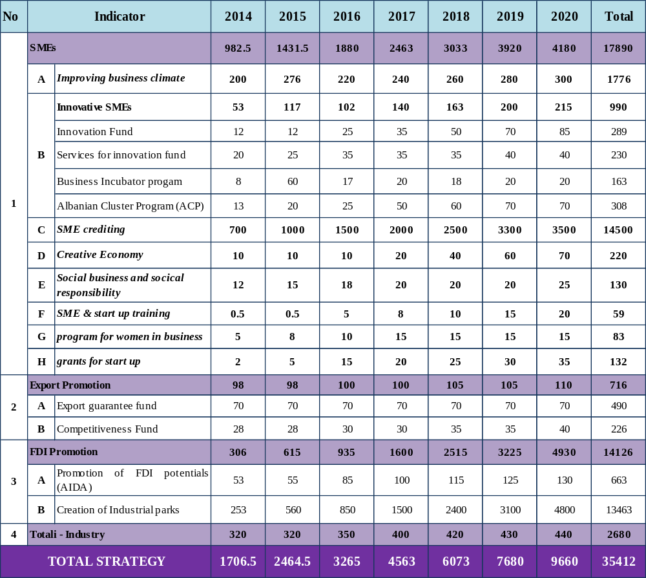
V. STRATEGY MONITORING INDICATORS

Success in the evaluation of the monitoring indicators 2013 - 2020 shall be made according to 2 groups:

1. Grouping monitoring indicators defined by the pillars of this strategy.
Based on key sectors that form the basis of this strategy, the monitoring will be carried out by
monitoring sector of MEDTE strategies in collaboration with the directorates that are responsible for specific objectives as Directorate of Entrepreneurship Support, Directorate of economic collaboration and foreign relations, AIDA etc. Based on the action plan for the implementation of this strategy, in order to directly and every year, the action plan will be an integral part of each directorate's annual plan covering the sectors of this strategy:

Directorate of Entrepreneurship Support will be responsible for the implementation of the action plan in accordance with the objectives set for the business climate, entrepreneurship and SME sector, the sector of export promotion and foreign investment promotion.
Directorate of economic collaboration and foreign relations will be responsible for the implementation of the action plan and targets for reducing administrative costs and eliminating non-tariff trade barriers.

Annually will be monitored the progress of implementation of the basic indicators of this strategy. By providing a close collaboration with institutions such as INSTAT, Bank of Albania, the Directorate General of Customs, AKBN, AIDA, etc., in order to collect the database which will ensure the dynamics of development of determine indicators according to the years of this strategy.

2. International Benchmarking

Ranking of Albania in global benchmarking will be a transparent and measurable indicator for the success of the strategy, which will be based on evaluation of international reports.

WB report on “Doing Business” as the main benchmark.

Remains an aim and the ambition of the Albanian government to be ranked between the best 50 in al key indicators of global ranking on the easiness of doing business and competitiveness and leadership in south east Europe.
http://www.doingbusiness.org/
http://www.doingbusiness.org/

SME policy index according to EU SBA
SME policy index is an evaluating report for the countries of the western Balkans in order to monitor and evaluate progress in the main frame work for the development of SME policies.

http://www.oecd.org/pages/0,3417,en_35424885_37776794_1_1_1_1_1,00.html http://www.oecd.org/pages/0,3417,en_35424885_37776794_1_1_1_1_1,00.html

It is the aim and the ambition of GoA to be a leader in the SEE among the countries of the region.
- an additional benchmark to be included, e.g. the Gender Gap Index of the World Economic

Forum (http://www.weforum.org/issues/global-gender-gap).

Regional Cooperation Council, RCC, implementation of SEE 2020
Starting from January 2012, the SEE investment committee co-directed with the Regional Cooperation Council, OECD Investment Compact continues to offer support in the growth of regional competitiveness and business climate, especially for the implementation of the 2020 vision. http://www.rcc.int

It is the aim and the ambition of GoA to be a leader in the SEE among the countries of the region.

Global Competitiveness Index GCI
The world economic forum publishes every year data on the competitiveness of the economies of the countries.
http://reports.weforum.org/global-competitiveness-2011-2012/#
http://reports.weforum.org/global-competitiveness-2011-2012/#

Economic Freedom Index
Fraser and Heritage Institutions, both of them in the North America publish every year indicators focused on the economic freedom.
http://www.fraserinstitute.org/research-news/research/display.aspx?id=16613 http://www.heritage.org/index/explore

Strategy indicators

In this area clear and measurable numeric indicators allow transparency and focus on the achievement of the aims in this period 2014-2020:

- Further improvement of the business climate considering:

- Reduce the time of opening a business from 5 days in 2013 to 2 days, Reduction of procedures to start a business from 5 to 2;
- Reduction of days to obtain construction licenses from 436 days to 35 days, Improvement of service online tax payment etc.

- For innovative SME and entrepreneurship:
- Creation of 1 technology business incubators;
- Creation of 3 new clusters;
- Support of 300 businesses with information and innovation grants;
- Creation of the program to support 100 women-led businesses through low interest loans
- Creation of the program to support 400 new businesses (start-up), through grant funds and low interest loans;
- Creating a fund to support 470 creative businesses, especially those in the field of handicrafts with grants.

- For the internationalization of SME:
- Supporting of 254 companies with grants to increase their competitiveness;
- Supporting of 100 exporting companies with export guarantee funds.

- Industry:
- Increase of turnover of industry sectors with an annually average by 7.3%;
- Increase of added value with a yearly average of 10%;
- Increase of productivity each year with an average of 5%.

- Exports:
- The growth of exports of goods each year with an average of 9%.

- Employment:
- Referred to 2013 as the baseline, it is foreseen that number of employment increase till 2020 about 40.7% or 116,000 job creation in the private non-agriculture sector.

- Attracting Foreign Direct Investment:
- Referred to 2013 as the baseline, it is foreseen an increase of 45% or 385 Mil. Euro of FDI till 2020.

Monitoring of business and investment strategy shall be made through these indicators:

Indicators | Unit | 2013 | 2014 | 2015 | 2016 | 2017 | 2018 | 2019 | 2020
Business Climate
No. of days to open a business |  | 5 | 5 | 4 | 3 | 2 | 2 | 2 | 2
No. of procedures to open e new business |  | 5 | 5 | 4 | 3 | 2 | 2 | 2 | 2
SMEs Performance
No. of active enterprises | 000/nd | 113 | 115 | 117 | 119 | 121 | 123 | 125 | 127
Increase by % no. of enterprises | % | 1.8 | 1.8 | 1.7 | 1.7 | 1.7 | 1.7 | 1.6 | 1.6
No. of employees |  | 285 | 299 | 314 | 330 | 346 | 364 | 382 | 401
Increase in % of employees |  | 4% | 5% | 5% | 5% | 5% | 5% | 5% | 5%
No. of woman-led companies as a Total % | % | 28% | 29% | 30% | 31% | 32% | 33% | 34% | 35%
Disbursed credits by business women | % | 29% | 30% | 31% | 32% | 33% | 34% | 34,5% | 35%
Innovative SMEs
Technology Incubators | nr |  |  |  |  |  |  |  | 1
Cluster creation | nr |  |  |  |  |  | 1 | 1 | 1
Exports
Export of goods total (X) | Mln/€ | 1668 | 1818 | 1981 | 2160 | 2354 | 2566 | 2797 | 3049
Increase in % of exports | % | 9% | 9% | 9% | 9% | 9% | 9% | 9% | 9%
Export Contribution to GDP | % | 16% | 17% | 18% | 18% | 19% | 9% | 20% | 20%
FDI
Total FDI | Mln/€ | 855 | 855 | 905 | 1040 | 1100 | 1152 | 1199 | 1248
Increase in % of FDI | % | 14% | 14% | 5.8% | 5.0% | 5.8% | 4.7% | 4.1% | 4.1%
FDI as a % of GDP |  | 8.3% | 8.3% | 8.0% | 8.7% | 8.8% | 8.6% | 8.5% | 8.3%
Competitiveness
Competitiveness Indicator / Score |  | 4.1 | 4.15 | 4.2 | 4.25 | 4.3 | 4.35 | 4.4 | 4.5
Competitiveness indicator / Ranking
Industry
Increase in % of turnover | % | 5% | 7% | 7% | 8% | 8% | 8% | 8% | 8%
Increase in % of Added Value | % | 6% | 10% | 10% | 10% | 10% | 10% | 10% | 10%
Increase in % of productivity | % | 5% | 5% | 5% | 5% | 5% | 5% | 5% | 5%

VI. STRATEGY ANNEXES

As annexed to this strategy is the action plan for the implementation of the strategy for the period 2014-2020

Eurostat, New Cronos database: PPP domain/ 13.12.2011
In June 2008 the European Commission adopted the Small Business Act, (SBA), as important policy document. The effective implementation of this principle is one of the most important obligations of the Albanian government, because as this is considered part of the Stabilization Association process with the EU.
UNCTAD WIR 2013
United Nations Population Division, Department of Economic and Social Affairs, 2013

